

Parking Management System

Database Management System

Name : Suraj Shah, Jeet Shekhda

Roll no. : 22BCE326, 22BCE330

Course : DBMS

Course Code : 2CS505

Innovative Assignment - Report

# Introduction / Problem Statement:

* Parking Management System is a system that provides us with reserving parking area , checking whether the parking are vacant or not etc by using online browsing. This system is very useful to all, especially for business people. For Business people they don’t have sufficient time for these then they can use these types of online parking Management Systems. Parking Management system is not allowed wapon and not responsibility of your expansive Thing.
* In conclusion, the Parking Management System in DBMS project aims to address the growing parking challenges in urban areas by offering an efficient, user-friendly, and data-driven solution. This system will not only benefit parking operators but also improve the overall urban mobility experience, making cities more accessible and sustainable.

# Existing Work:

**Traditional Parking Management Systems:**

The allocation of parking spaces, processing of payments, and monitoring are all done manually in traditional parking management systems.These systems frequently include manual record-keeping, paper-based ticketing systems, and live parking attendants.They lack real-time data analytics capabilities and are prone to mistakes and inefficiencies.

**Smart Parking Systems:**

For parking management, smart parking systems make use of technology such as sensors, Internet of Things (IoT) devices, and mobile applications. Convenient user experiences, cashless payment capabilities, and real-time parking availability information are all provided by these systems. But putting them into practice can be costly, and it could be necessary to make major infrastructure improvements.

**Mobile Parking Apps:**

Users can get parking management services through a number of mobile applications. These apps let users pay for things, find and reserve parking spots, and get alerts. Nevertheless, they could not work well with the current parking infrastructure and are frequently restricted to particular geographic regions.

**Background :**

The need for effective parking operation systems has come decreasingly apparent with the rapid-fire urbanization and growth of metropolises worldwide. Civic areas face significant challenges related to parking, including traffic, shy parking structure, and hamstrung application of parking spaces. Traditional parking operation styles have proven shy in addressing these challenges, egging the development of ultramodern results.  
  
Urbanization and Parking Demand  
  
Urbanization has led to a rise in the number of vehicles, aggravating parking traffic in metropolises.  
As metropolises grow, the demand for parking spaces increases, performing in overcrowded parking lots and thoroughfares.  
shy parking structure fails to meet the requirements of residers, businesses, and callers, leading to frustration and inefficiency.  
Business Traffic and Environmental Impact  
  
Parking traffic contributes to business traffic and air pollution in civic areas.  
Vehicles circling in hunt of parking spaces waste energy, increase emigrations, and worsen business traffic.  
Addressing parking challenges is pivotal for reducing the environmental impact of transportation and perfecting air quality.  
Inefficiencies of Traditional Systems  
  
Traditional parking operation systems, counting on homemade processes and paper- grounded marking, are hamstrung and error-prone.  
These systems struggle to handle the adding volume of vehicles and fail to give real- time information on parking vacuity.  
Homemade record- keeping leads to data inconsistencies and makes it delicate to dissect parking patterns and trends.  
Emergence of Smart Technologies  
  
With advancements in technology, smart parking results have surfaced to address the failings of traditional systems.  
Smart parking systems influence technologies similar as detectors, IoT bias, and mobile operations to ameliorate parking operation.  
These systems give real- time information on parking vacuity, enable cashless payments, and optimize parking application.  
Integration with Civic Mobility results  
  
ultramodern parking operation systems are decreasingly integrated with broader civic mobility platforms.  
Integrated platforms offer flawless trip gests by combining parking services with public transportation, lift- sharing, and other mobility options.  
They aim to reduce reliance on private vehicles, promote sustainable transportation, and ameliorate overall civic mobility.  
Government enterprise and Regulations  
  
Governments around the world are enforcing programs and regulations to address parking issues.  
enterprise include erectingmulti-level parking structures, enforcing smart parking measures, and promoting indispensable transportation modes.  
Regulations may include parking restrictions, pricing programs, and impulses for using public transportation.  
Conclusion  
The background of the Parking operation System design is embedded in the pressing need to address parking challenges in civic areas. It aims to work ultramodern technology and data- driven approaches to optimize parking application, reduce traffic, and enhance the overall civic mobility experience. By furnishing an effective, stoner-friendly, and scalable result, the design seeks to contribute to the enhancement of parking operation in metropolises.

**Challenges and the problems faced:**

**Understanding Requirements:**

Initially, understanding the detailed requirements of the parking management system was challenging.

Clarifying ambiguities and ensuring all functionalities were captured accurately required thorough analysis.

**Database Design Complexity:**

Designing a robust and normalized database schema to accommodate various entities and relationships was complex.

Ensuring data integrity and efficient querying while avoiding redundancy posed a challenge.

**Implementing Functionalities:**

Implementing various functionalities like user registration, authentication, parking slot allocation, and payment processing was challenging.

Ensuring smooth flow between different modules while maintaining data integrity was crucial.

# ER diagram :

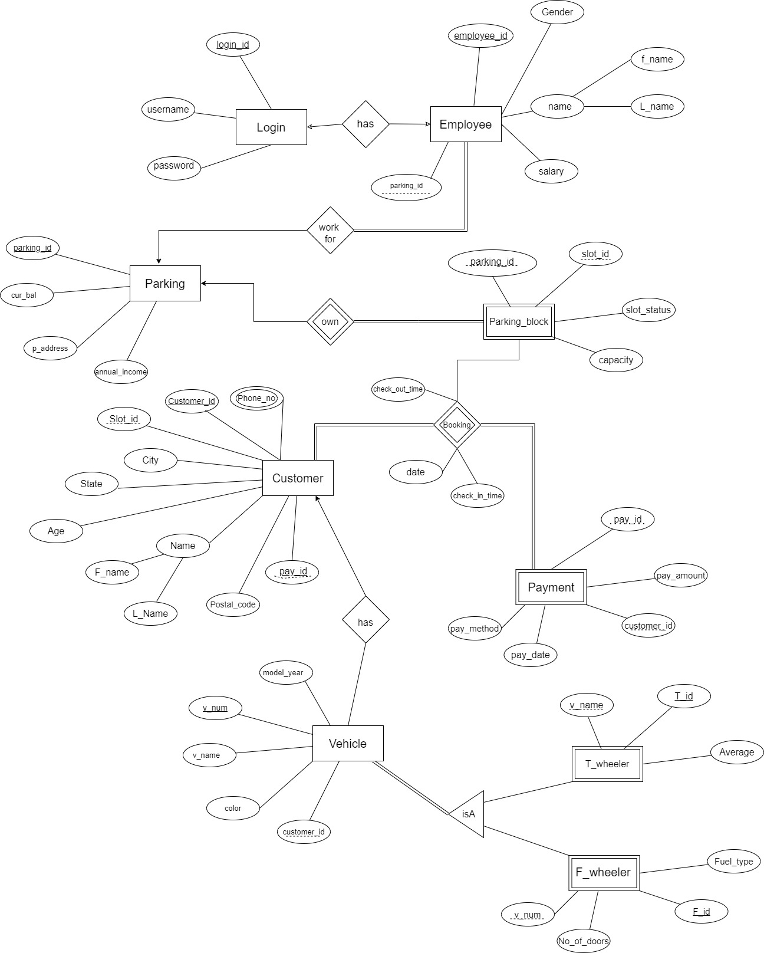

# Relational Model:

Login(login_id , username , password)

Employee (employee_id ,parking_id, f_name , l_name , gender , salary )

Parking ( parking_id , annual income , p_address , cur_bal)

Parking_block (slot_id ,paking_id , slot_status , capacity )

Payment ( pay_id , customer_id , pay_method , pay_date , pay_amount)

Customer (customer_id ,sloat_id, f_name , l_name , phone_no , gender, age , city , state , postal_code )

Booking (customer_id,sloat_id, date , check_in_time , check_out_time)

Vehicle ( customer_id, v_num , v_name , color , model_year)

Two_wheeler( t_id , v_num, average)

Four_wheeler( f_id , v_num, fueltype , no_of_doors)

## Data Dictionary:

Login:

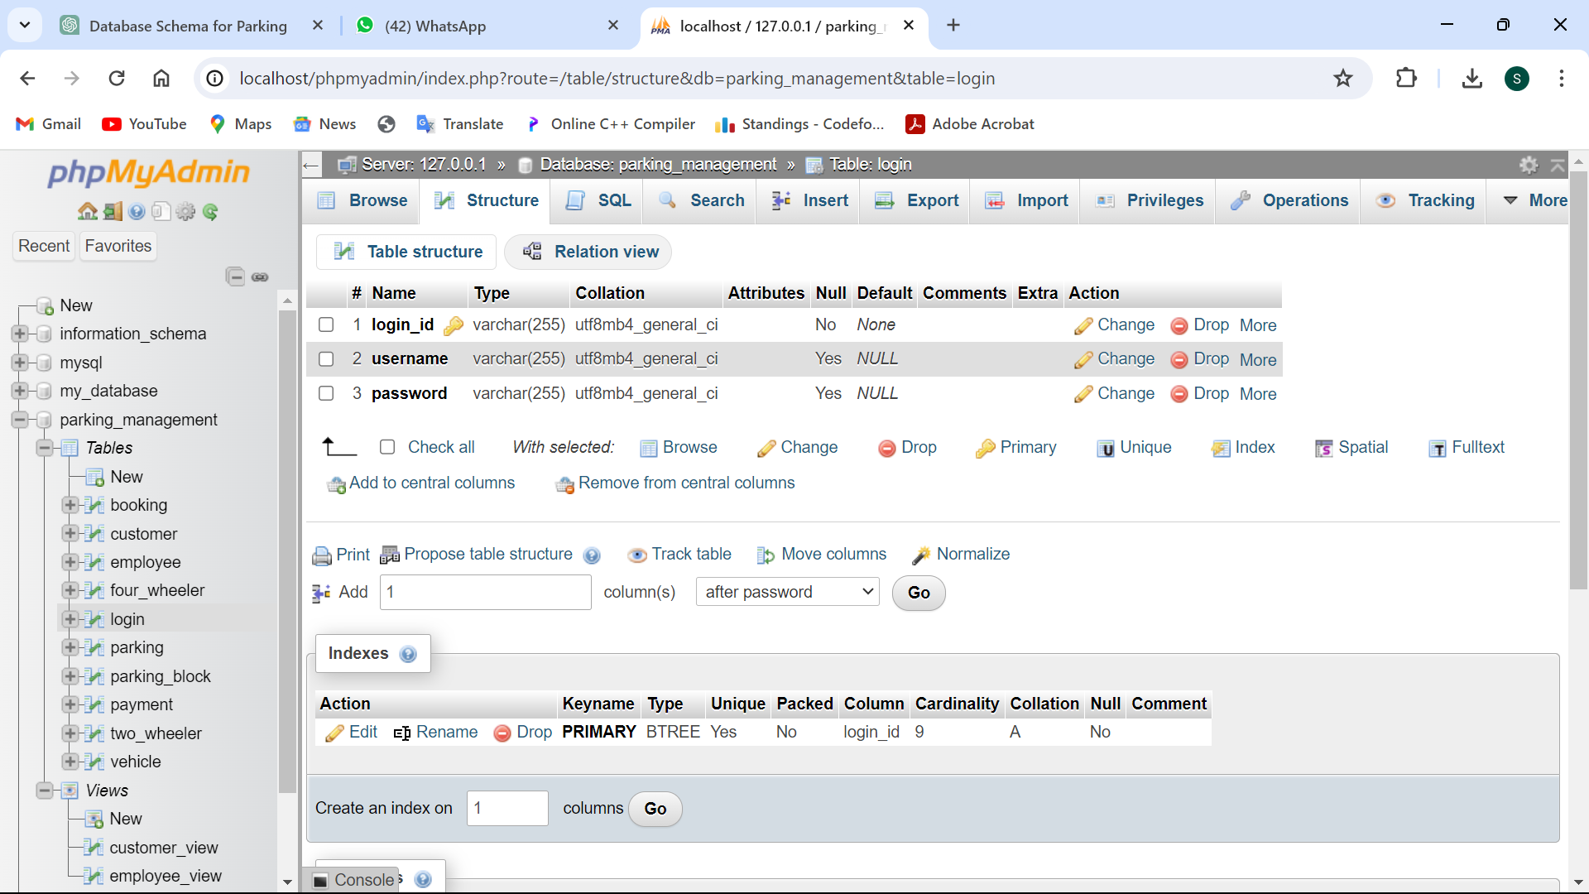

Employee:

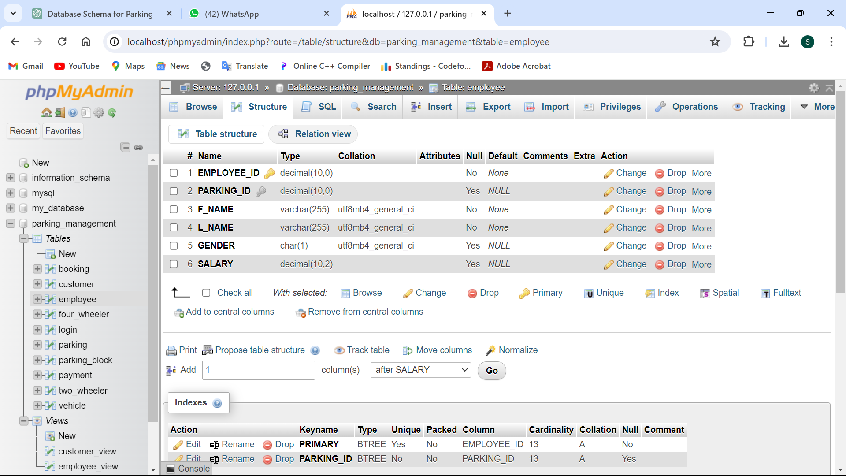

Parking:

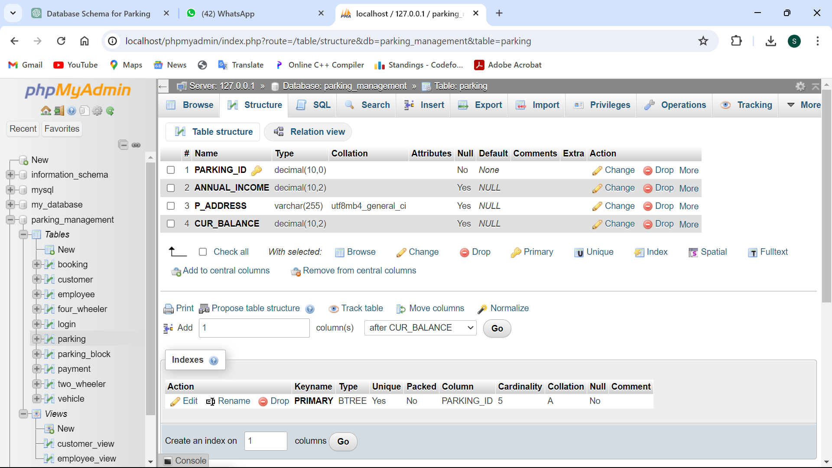

Parking_block:

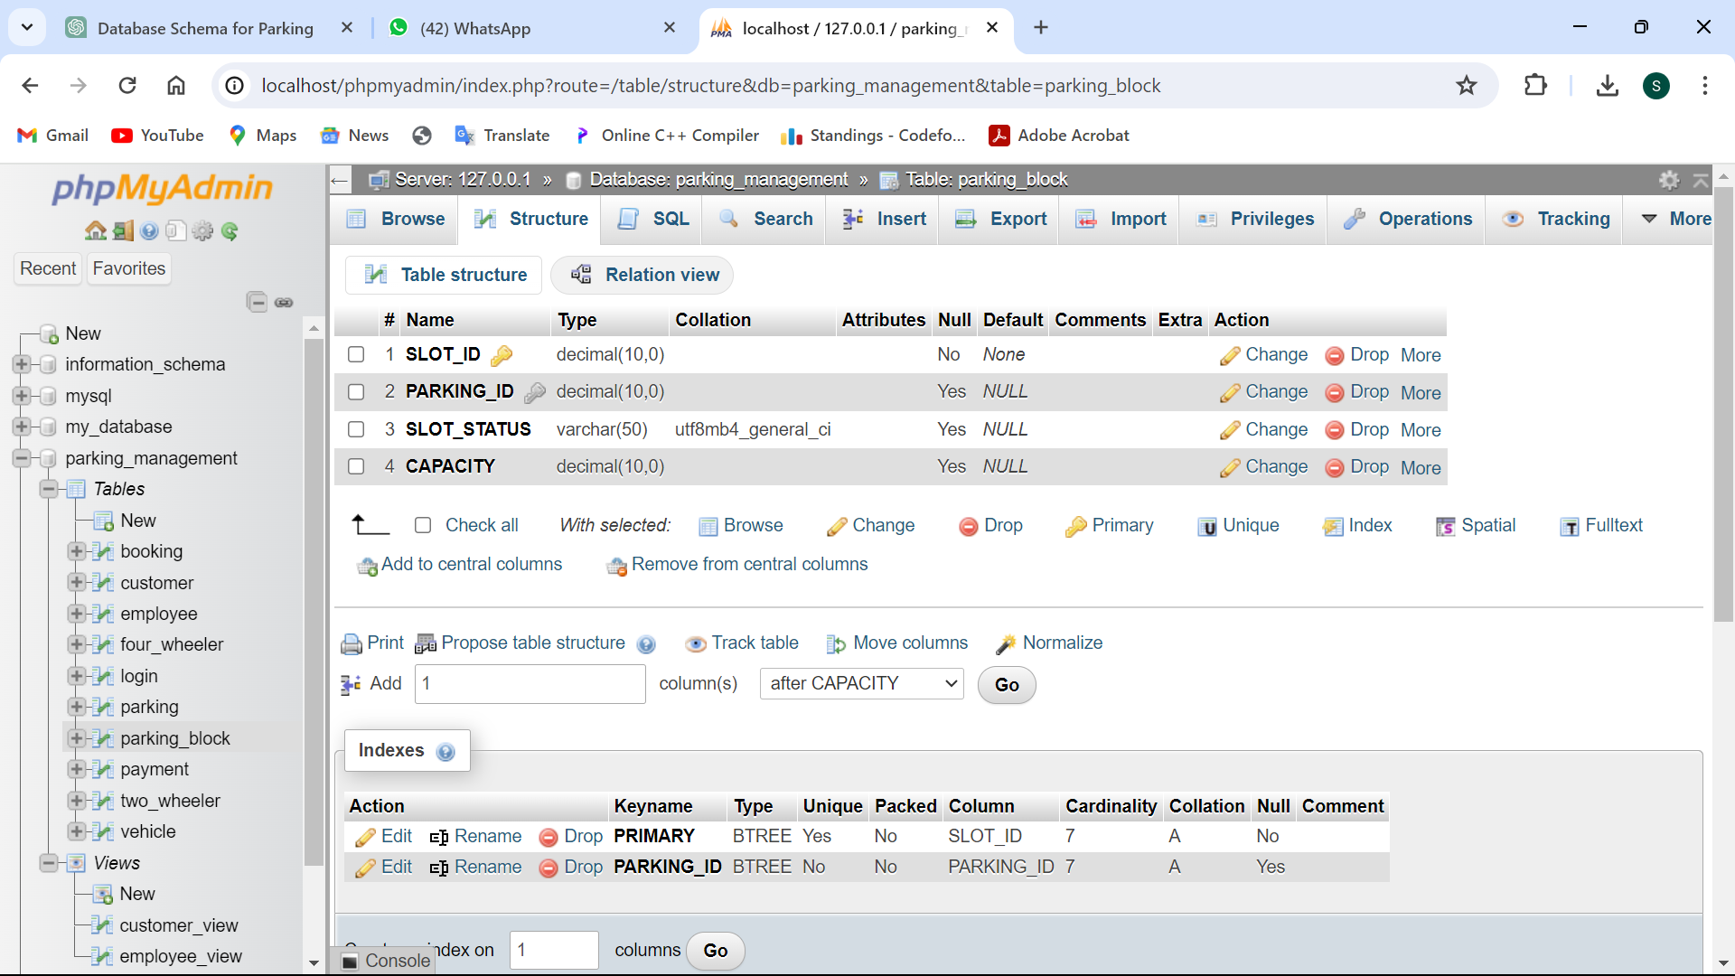

Payment:

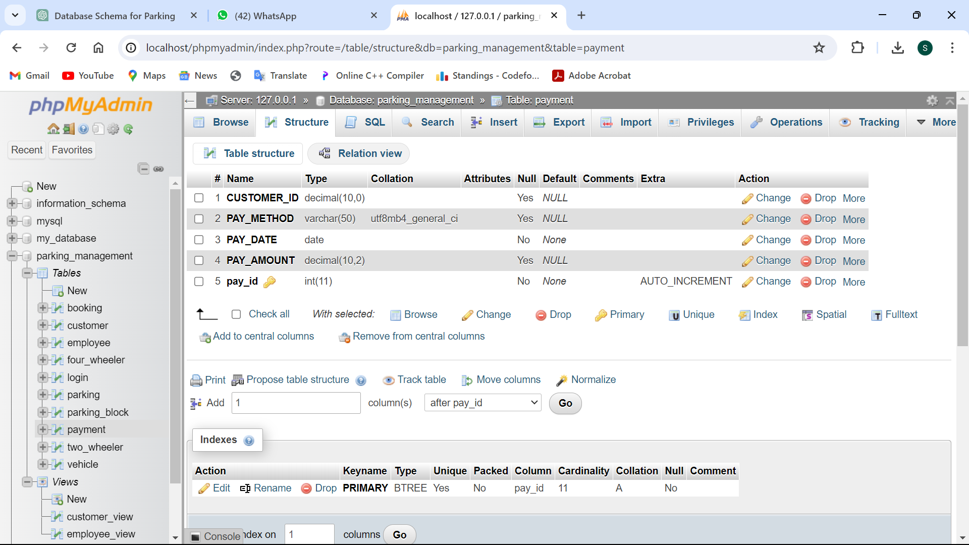

Customer:

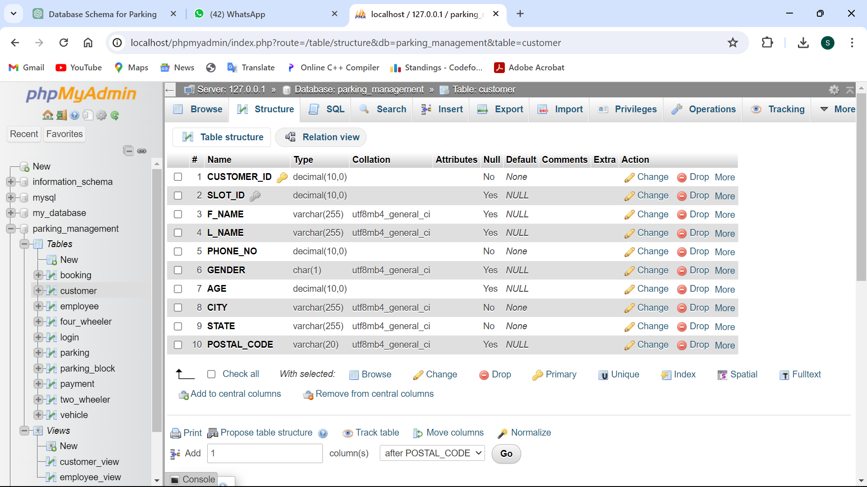

Booking:

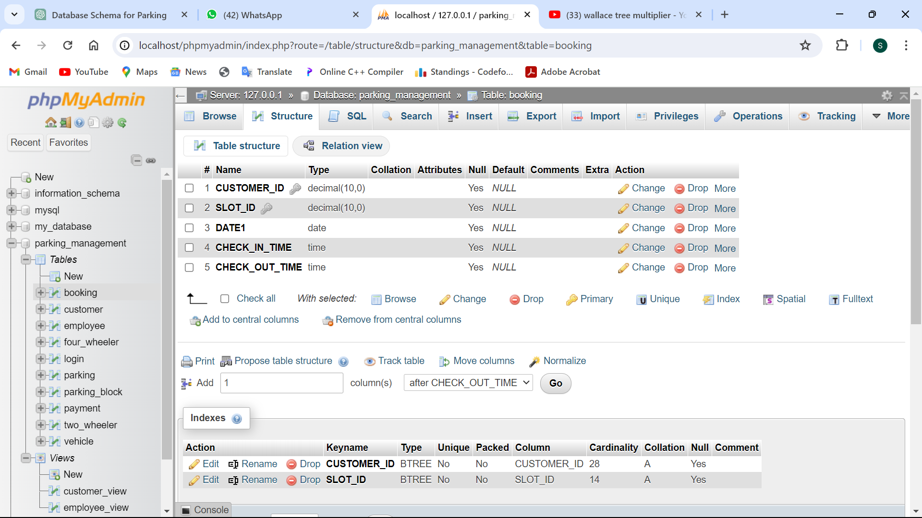

Vehicle:

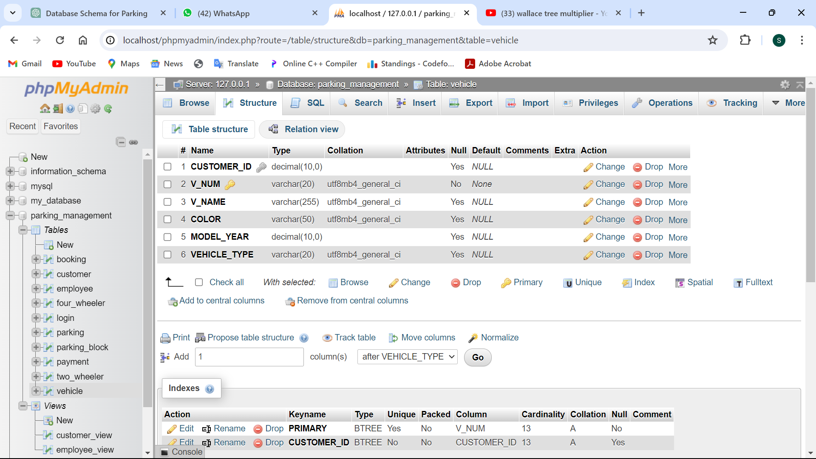

Two_wheeler:

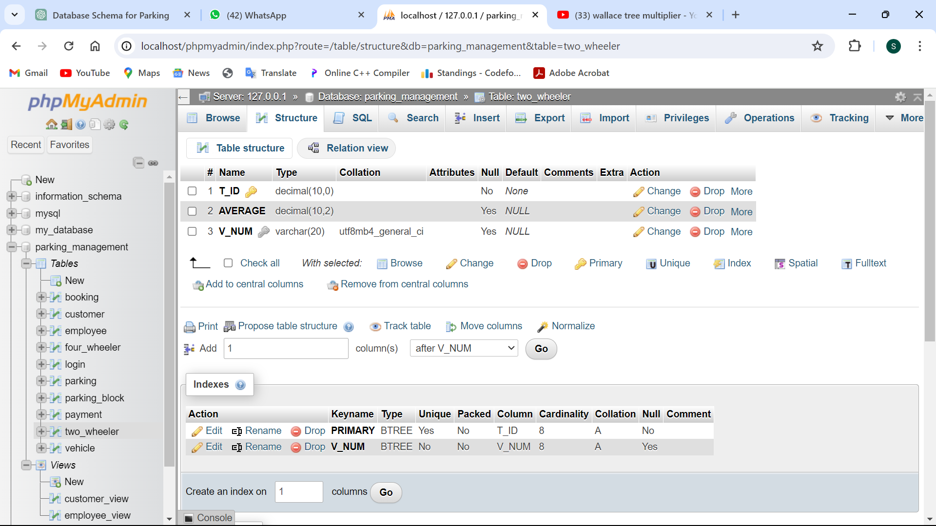

Four_wheeler:

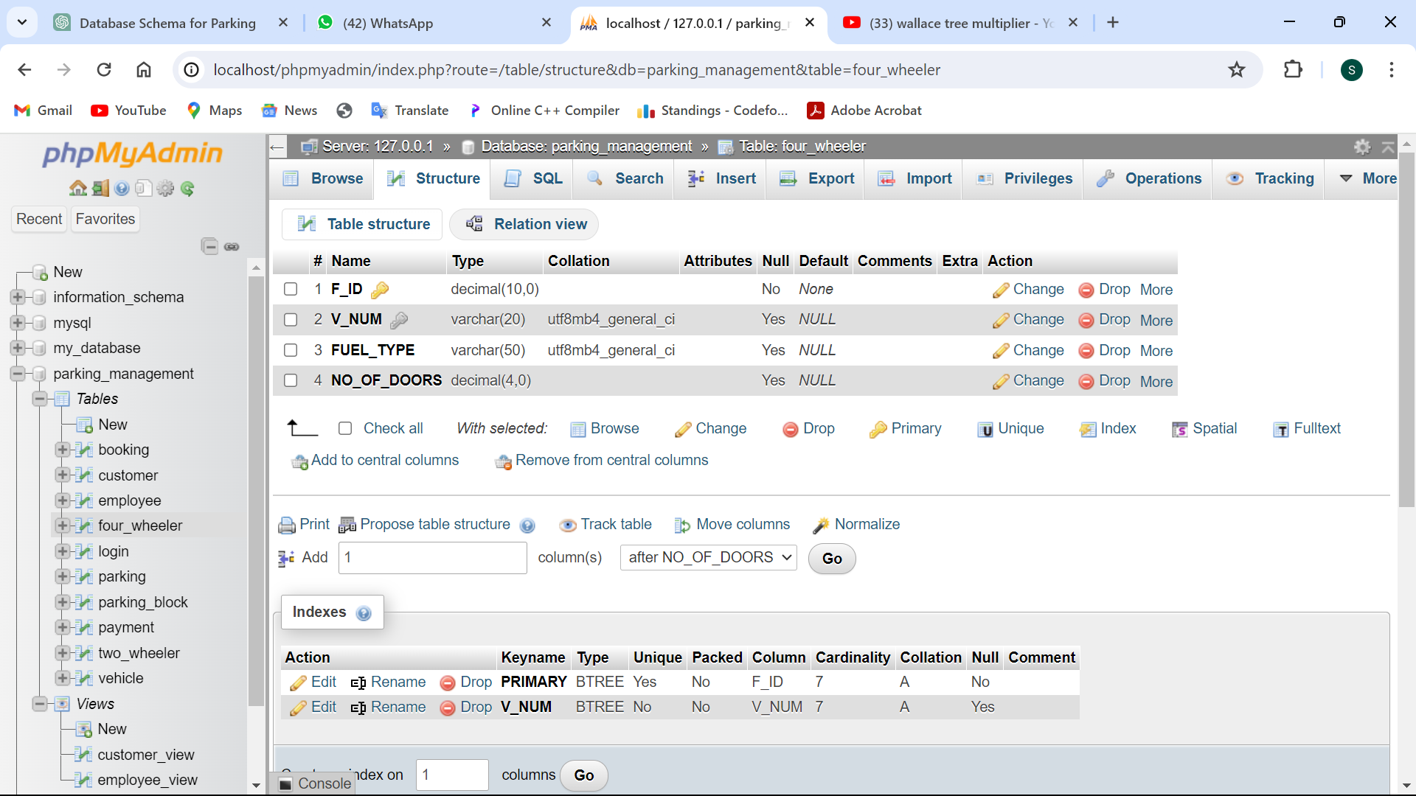

# Data Implementation:

### Schema

Login:

CREATE TABLE login (login_id VARCHAR(255) PRIMARY KEY, username VARCHAR(255), password VARCHAR(255));

Employee:

CREATE TABLE employee (EMPLOYEE_ID NUMERIC(10) PRIMARY KEY, PARKING_ID NUMERIC(10), F_NAME VARCHAR(255) NOT NULL, L_NAME VARCHAR(255) NOT NULL, GENDER CHAR(1), SALARY NUMERIC(10, 2), FOREIGN KEY (PARKING_ID) REFERENCES PARKING(PARKING_ID));

Parking:

CREATE TABLE PARKING (PARKING_ID NUMERIC(10) PRIMARY KEY, ANNUAL_INCOME NUMERIC(10, 2), P_ADDRESS VARCHAR(255), CUR_BALANCE NUMERIC(10, 2));

Parking_block:

CREATE TABLE PARKING_BLOCK (SLOT_ID NUMERIC PRIMARY KEY, PARKING_ID NUMERIC (10), SLOT_STATUS VARCHAR(50), CAPACITY NUMERIC (10), FOREIGN KEY (PARKING_ID) REFERENCES PARKING(PARKING_ID));

Payment:

CREATE TABLE PAYMENT (CUSTOMER_ID NUMERIC (10), PAY_METHOD VARCHAR(50), PAY_DATE DATE NOT NULL , PAY_AMOUNT NUMERIC(10, 2), PAY_ID NUMERIC (10) AUTO_INCREMENT PRIMARY KEY);

Customer:

CREATE TABLE CUSTOMER (CUSTOMER_ID NUMERIC (10) PRIMARY KEY, SLOT_ID NUMERIC (10), F_NAME VARCHAR(255), L_NAME VARCHAR(255), PHONE_NO NUMERIC (10) NOT NULL, GENDER CHAR(1), AGE NUMERIC (10), CITY VARCHAR(255) NOT NULL , STATE VARCHAR(255) NOT NULL , POSTAL_CODE VARCHAR(20), FOREIGN KEY (SLOT_ID) REFERENCES PARKING_BLOCK(SLOT_ID));

Vehicle:

CREATE TABLE VEHICLE (CUSTOMER_ID NUMERIC(10), V_NUM VARCHAR(20) PRIMARY KEY, V_NAME VARCHAR(255), COLOR VARCHAR(50), MODEL_YEAR NUMERIC(10), FOREIGN KEY (CUSTOMER_ID) REFERENCES CUSTOMER(CUSTOMER_ID));

Two_wheeler:

CREATE TABLE TWO_WHEELER (T_ID NUMERIC(10) PRIMARY KEY, AVERAGE NUMERIC(10, 2), V_NUM VARCHAR(20), FOREIGN KEY (V_NUM) REFERENCES VEHICLE(V_NUM));

Four_wheeler:

CREATE TABLE FOUR_WHEELER (F_ID NUMERIC(10) PRIMARY KEY, V_NUM VARCHAR(20), FUEL_TYPE VARCHAR(50), NO_OF_DOORS NUMERIC(4), FOREIGN KEY (V_NUM) REFERENCES VEHICLE(V_NUM));

Booking:

CREATE TABLE BOOKING (CUSTOMER_ID NUMERIC(10), SLOT_ID NUMERIC(10), DATE1 DATE, CHECK_IN_TIME TIME, CHECK_OUT_TIME TIME, FOREIGN KEY (CUSTOMER_ID) REFERENCES CUSTOMER(CUSTOMER_ID), FOREIGN KEY (SLOT_ID) REFERENCES PARKING_BLOCK(SLOT_ID));

### Data Insertion

Login:

INSERT INTO LOGIN (LOGIN_ID, USERNAME, PASSWORD) VALUES ('L1', 'user1', 'pass1'), ('L2', 'user2', 'pass2'), ('L3', 'user3', 'pass3'), ('L4', 'user4', 'pass4'), ('L5', 'user5', 'pass5'), ('L6', 'user6', 'pass6'), ('L7', 'user7', 'pass7'), ('L8', 'user8', 'pass8'), ('L9', 'user9', 'pass9');

Employee:

INSERT INTO employee (employee_id, parking_id, f_name, l_name, gender, salary) VALUES (1, 101, 'John', 'Doe', 'M', 50000), (2, 102, 'Jane', 'Smith', 'F', 60000), (3, 101, 'Michael', 'Johnson', 'M', 55000), (4, 103, 'smit' , 'patel' , 'M' , 15000 ), (5, 102, 'jimesh' , 'shah' , 'M' , 56000 ), (6, 104, 'shivani' , 'mehta' , 'F' , 10000 ), (7, 101, 'Michael', 'Johnson', 'M', 59000), (8, 104, 'shivani' , 'mehta' , 'F' , 10000 ), (9, 105, 'tirth' , 'doe' , 'M' , 89000 ), (10, 102, 'Jenish', 'Smith', 'M', 48000), (11, 103, 'travis' , 'head' , 'M' , 63000 );

Parking:

INSERT INTO parking (PARKING_ID, ANNUAL_INCOME,P_ADDRESS , CUR_BALANCE) VALUES (101, 50000,'' , 10000), (102, 60000, '', 15000), (103, 800000,'' , 30000), (104, 80000,'' , 30000), (105, 90000,'' , 40000);

Payment:

INSERT INTO PAYMENT (CUSTOMER_ID, PAY_METHOD,PAY_DATE , PAY_AMOUNT , PAY_ID) VALUES (1001 , 'cash' , '2008-09-11' , '1000' , 111 ), (1002 , 'online', '2020-12-09' , '1500' , 112 ), (1003 , 'cash' , '2022-04-02' , '3000' , 113), (1004 , 'NEFT' , '2021-11-09' , '1500' , 114 ), (1005 , 'online', '2008-01-19' , '6000' , 115), (1006 , 'NEFT' , '2009-03-09' , '3500' , 116 ), (1007 , 'online' ,'2001-09-12' , '2500' , 117), (1008 , 'NEFT' , '2012-10-25' , '6300' , 118 ), (1009 , 'NEFT' , '2019-11-29' , '2750' , 119);

Parking_block:

INSERT INTO parking_block (SLOT_ID, PARKING_ID, SLOT_STATUS, CAPACITY)VALUES (1, 101, 'Occupied', 50), (2, 101, 'Available', 150), (3, 102, 'Available', 200), (4, 102, 'Occupied', 80), (5, 103, 'Available', 40), (6, 104, 'Occupied', 60), (7, 105, 'Occupied', 100);

Customer:

INSERT INTO customer (CUSTOMER_ID, SLOT_ID, F_NAME, L_NAME, PHONE_NO, GENDER, AGE, CITY, STATE, POSTAL_CODE)VALUES (1001 , 1 , 'John' , 'Doe' , '1234567890' , 'M' , 30 , 'SURAT' , 'GUJRAT' , '10001'), (1002 , 2 , 'Jane' , 'Smith' , '0987654321' , 'F' , 25 , 'RAJKOT' , 'GUJRAT' , '90001'), (1003 , 3 , 'shlok' , 'tagadiya', '5551234567' , 'M' , 40 , 'MORBI' , 'GUJRAT' , '60601'), (1004 , 4 , 'krunal', 'Dudhatra', '1112223333' , 'F' , 35 , 'JAIPUR' , 'RAJASTHAN' , '77001'), (1005 , 5 , 'David' , 'Wilson' , '9998887777' , 'M' , 45 , 'SURAT' , 'GUJRAT' , '10001'), (1006 , 6 , 'Sarah' , 'Taylor' , '3334445555' , 'F' , 28 , 'PUNE' , 'MAHARASHTRA', '19101'), (1007 , 7 , 'jay' , 'borda' , '6667778888' , 'M' , 32 , 'AHMEDABAD', 'GUJRAT' , '78201'), (1008 , 1 , 'gazal' , 'gajera' , '2223334444' , 'F' , 50 , 'SURAT' , 'GUJRAT' , '10001'), (1009 , 2 , 'dax' , 'adroja' , '7778889999' , 'M' , 38 , 'RAJKOT' , 'GUJRAT' , '90001');

Booking:

INSERT INTO booking (CUSTOMER_ID , SLOT_ID , DATE1 , CHECK_IN_TIME , CHECK_OUT_TIME)VALUES (1001, 1, '2024-02-20', '09:00:00', '17:00:00'), (1002, 2, '2024-02-21', '10:00:00', '18:00:00'), (1003, 3, '2024-02-22', '11:00:00', '19:00:00'), (1004, 4, '2024-02-23', '12:00:00', '20:00:00'), (1005, 5, '2024-02-24', '13:00:00', '21:00:00'), (1006, 3, '2024-01-28', '18:00:00', '20:00:00'), (1007, 4, '2024-01-15', '09:00:00', '12:00:00'), (1008, 2, '2024-02-02', '20:00:00', '23:00:00');

Vehicle:

INSERT INTO vehicle (customer_id, v_num, v_name, color, model_year)VALUES (1001 , 'GJ-05-AB-0123' , 'Toyota Camry' , 'Blue' , 2022), (1001 , 'GJ-05-DE-1456' , 'Splender' , 'Red' , 2020), (1002 , 'GJ-03-GH-0789' , 'Ford Fusion' , 'Black' , 2024), (1002 , 'GJ-03-JK-8012' , 'Chevrolet Malibu' , 'Silver', 2017), (1003 , 'GJ-36-MN-1345' , 'Nissan Altima' , 'White' , 2016), (1003 , 'GJ-36-PQ-2678' , 'BMW 3 Series' , 'Gray' , 2021), (1004 , 'RJ-01-ST-7901' , 'shine' , 'Black' , 2015), (1004 , 'RJ-01-VW-9234' , 'Audi A4' , 'Silver', 2014), (1005 , 'GJ-05-YZ-5567' , 'dream yuga' , 'White' , 2022), (1005 , 'GJ-05-BC-0890' , 'Lexus ES' , 'Blue' , 2019), (1006 , 'MH-01-GH-7123' , 'Figo Ford' , 'Gray' , 2019), (1007 , 'GJ-01-MK-6456' , 'Nissan Altima' , 'Red' , 2016), (1008 , 'GJ-05-MK-8012' , 'Yamaha' , 'Black' , 2020);

Two_wheeler:

insert INTO two_wheeler (T_ID , AVERAGE , V_NUM) VALUES (11 , 65 , 'GJ-05-AB-0123'), (12 , 36 , 'GJ-05-MK-8012' ), (13 , 54 , 'GJ-05-YZ-5567' ), (14 , 72 , 'RJ-01-ST-7901'), (15 , 45 , 'GJ-05-YZ-5567' ), (16 , 35 , 'RJ-01-ST-7901'), (17 , 62 , 'GJ-05-AB-0123'), (18 , 72 , 'GJ-05-MK-8012' );

Four_wheeler:

INSERT INTO FOUR_WHEELER(F_ID,V_NUM,FUEL_TYPE,NO_OF_DOORS)VALUES (21 , 'GJ-05-AB-0123' , 'CNG' , 4), (22 , 'GJ-05-AB-0123' , 'PETROL' , 4), (23 , 'GJ-03-JK-8012' , 'ELECTRIC', 5), (24 , 'GJ-36-MN-1345' , 'CNG' , 4), (25 , 'GJ-36-PQ-2678' , 'CNG' , 5), (26 , 'GJ-05-AB-0123' , 'PETROL' , 4), (27 , 'GJ-05-BC-0890' , 'CNG' , 6);

### Insertion output

Login:

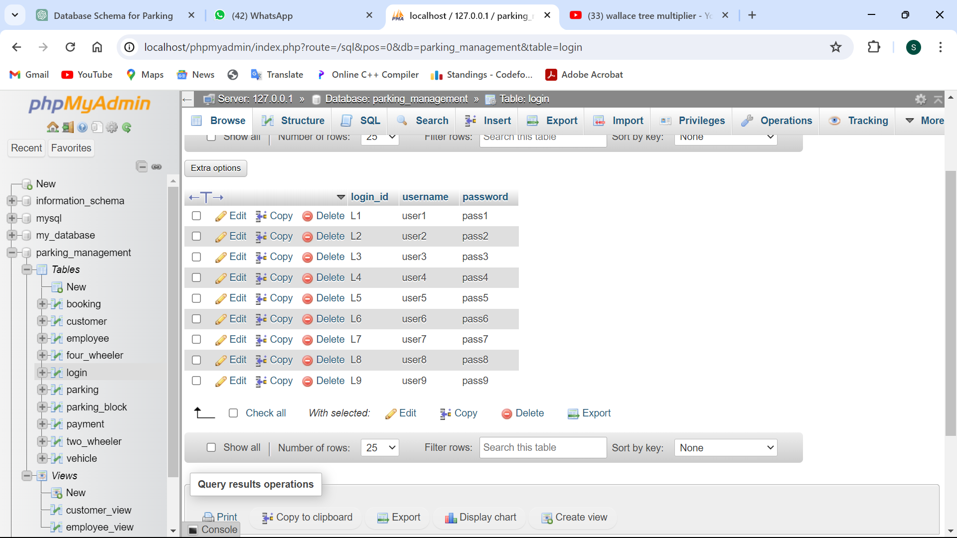

Employee:

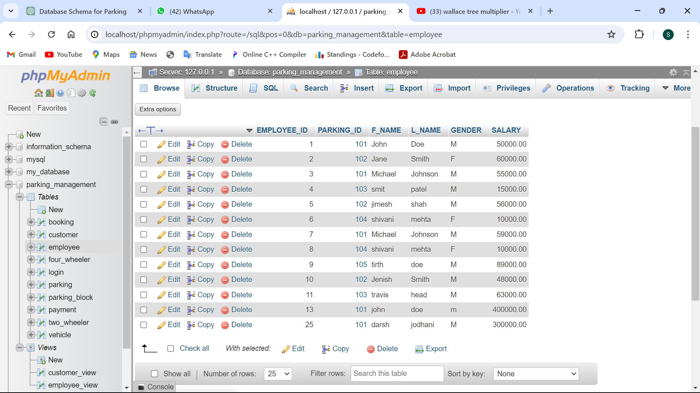

Parking:

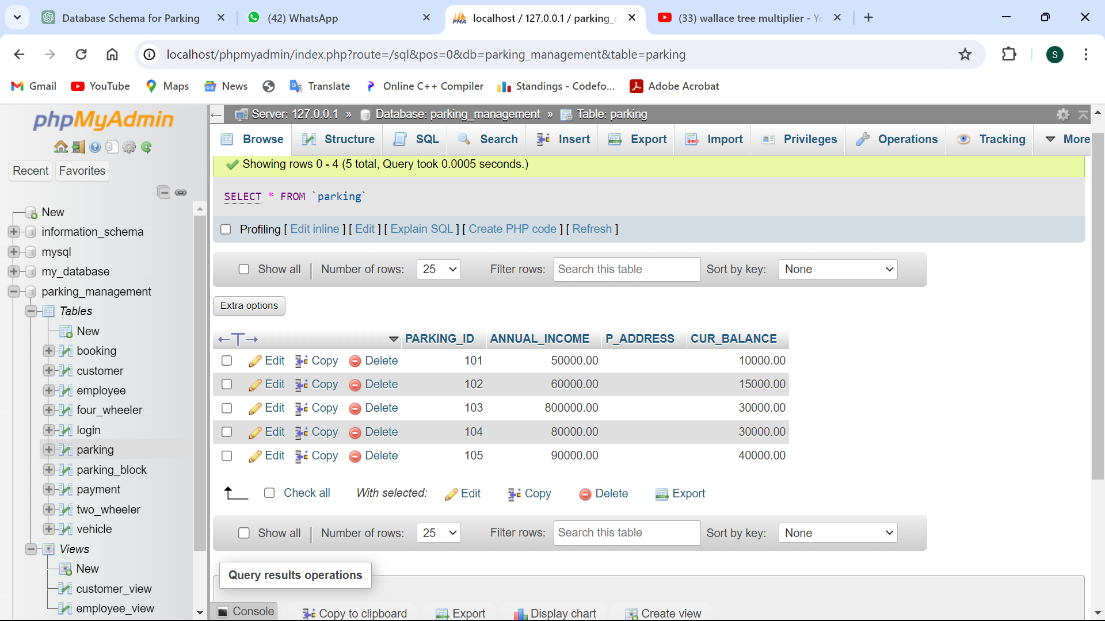

Parking_block:

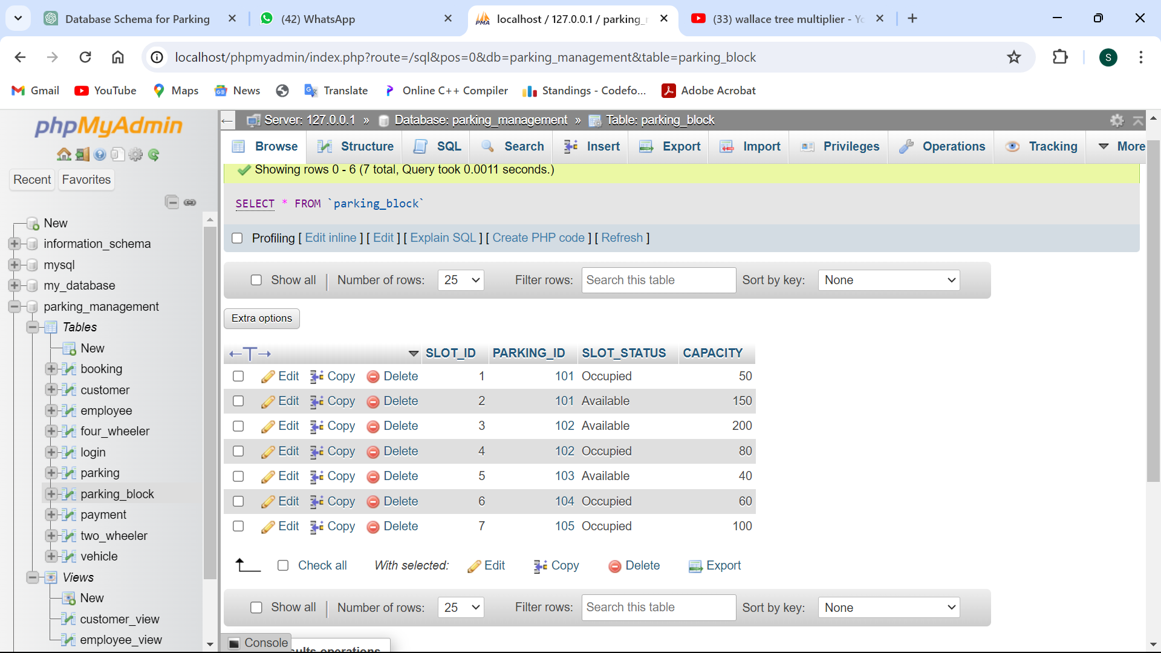

Payment:

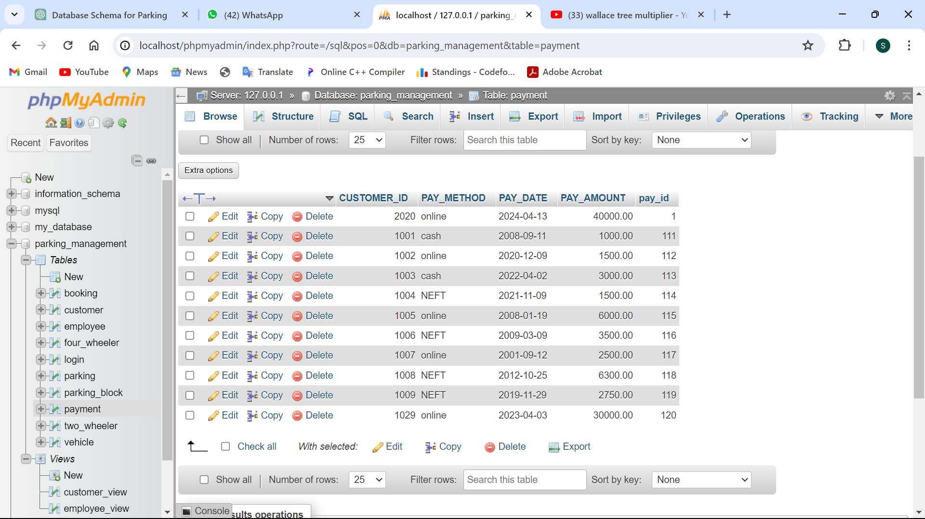

Customer:

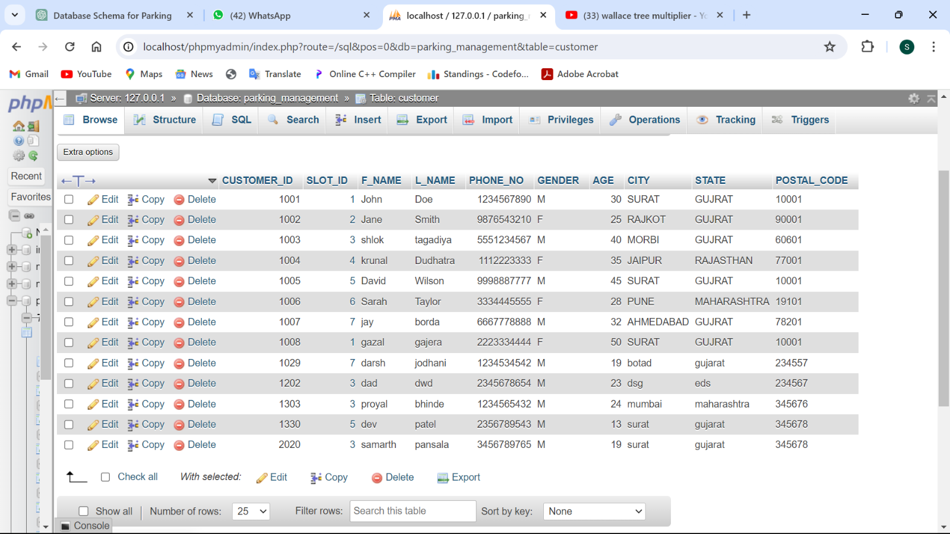

Vehicle:

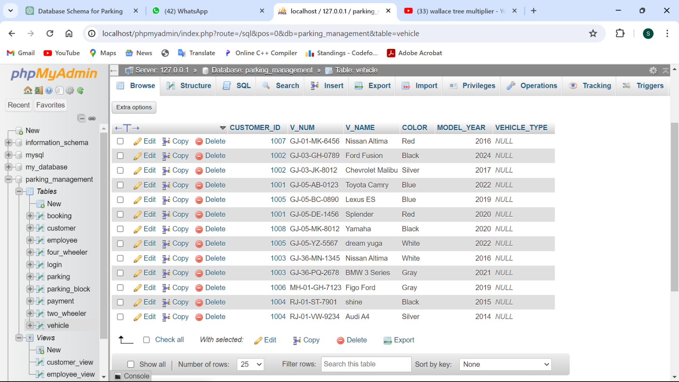

Booking:

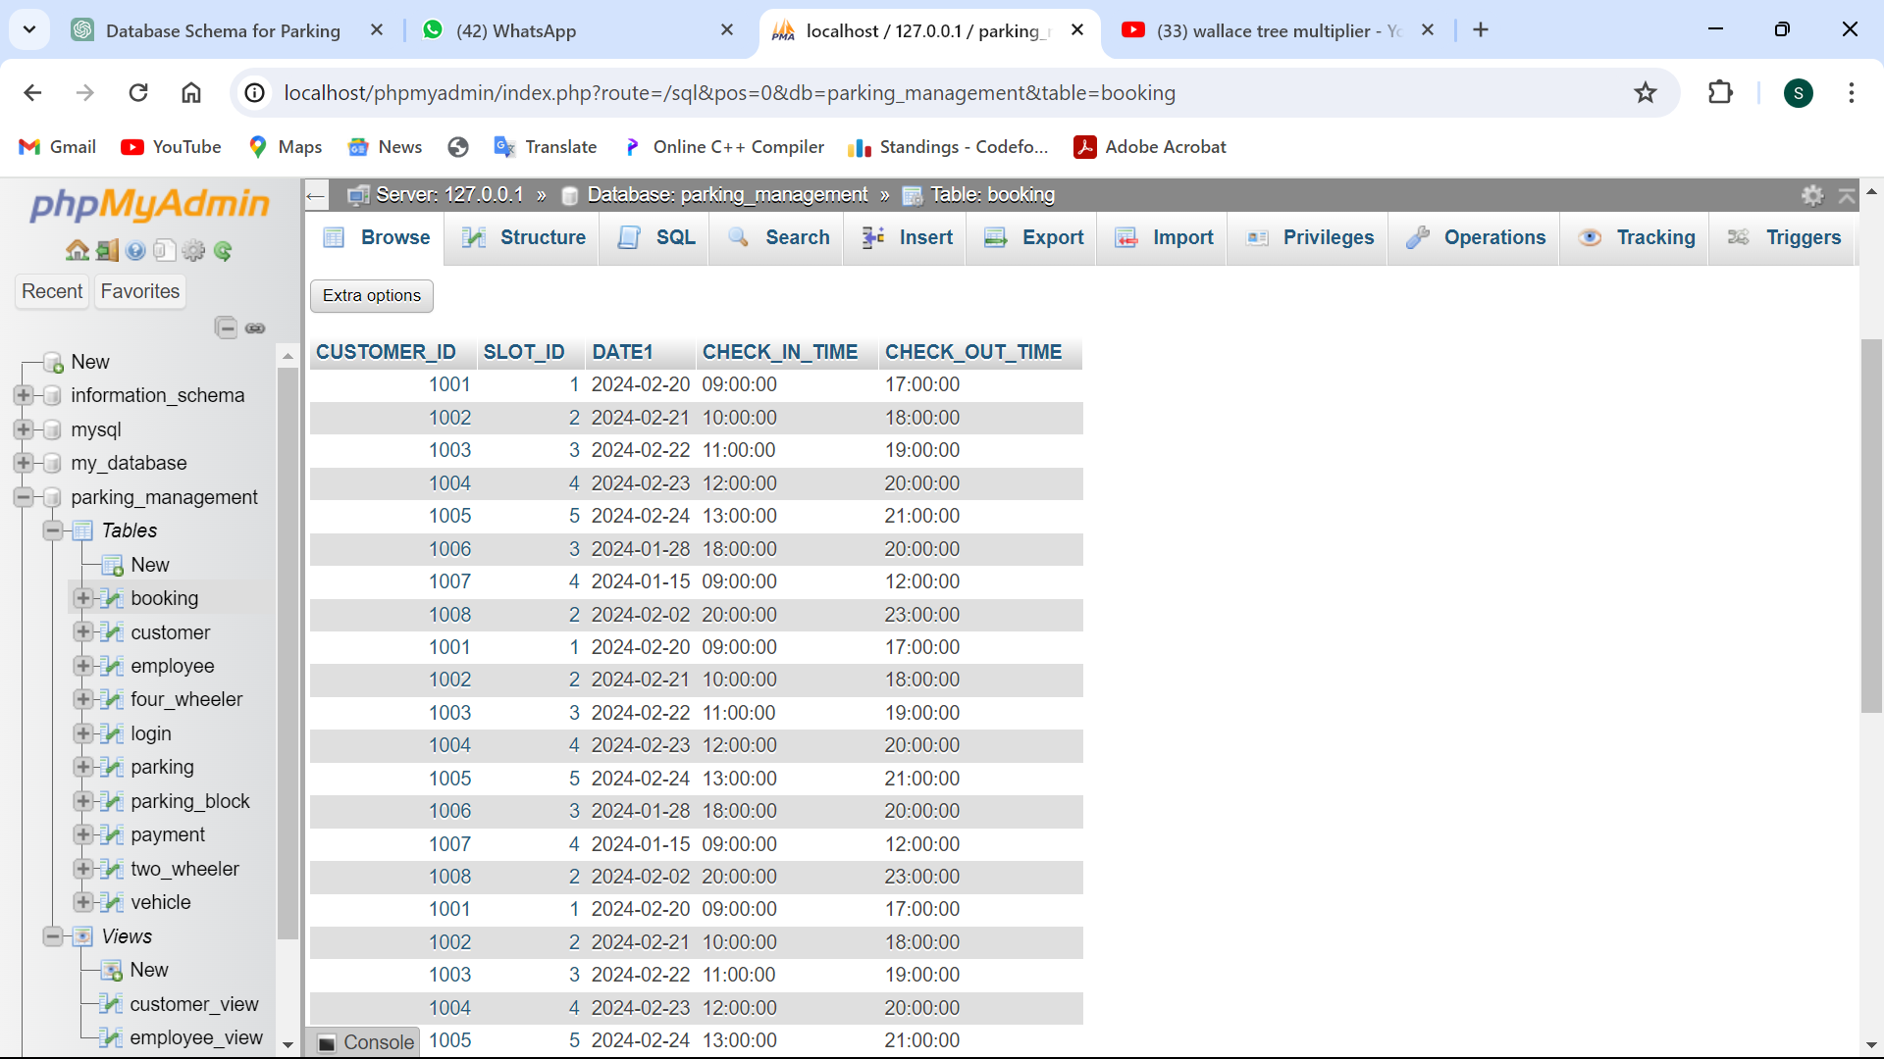

Two_wheeler:

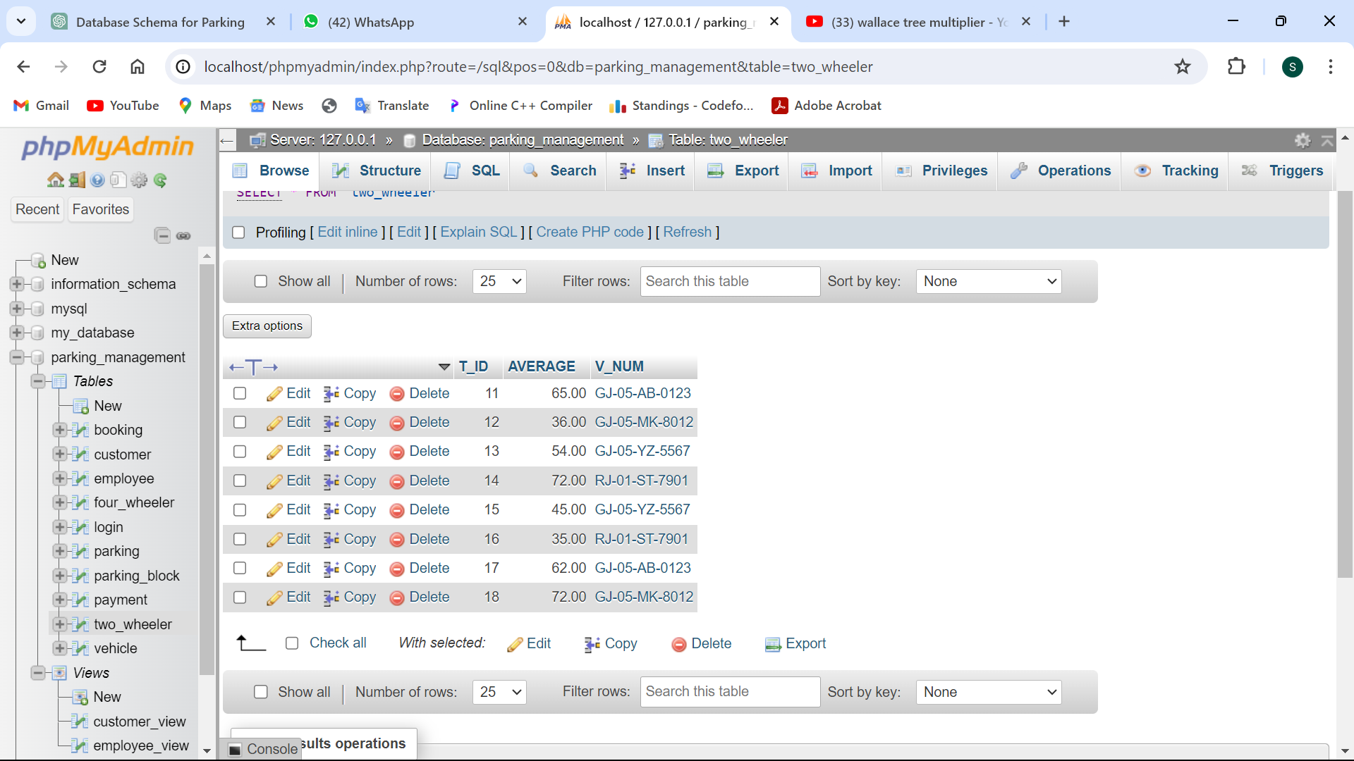

Four_wheeler:

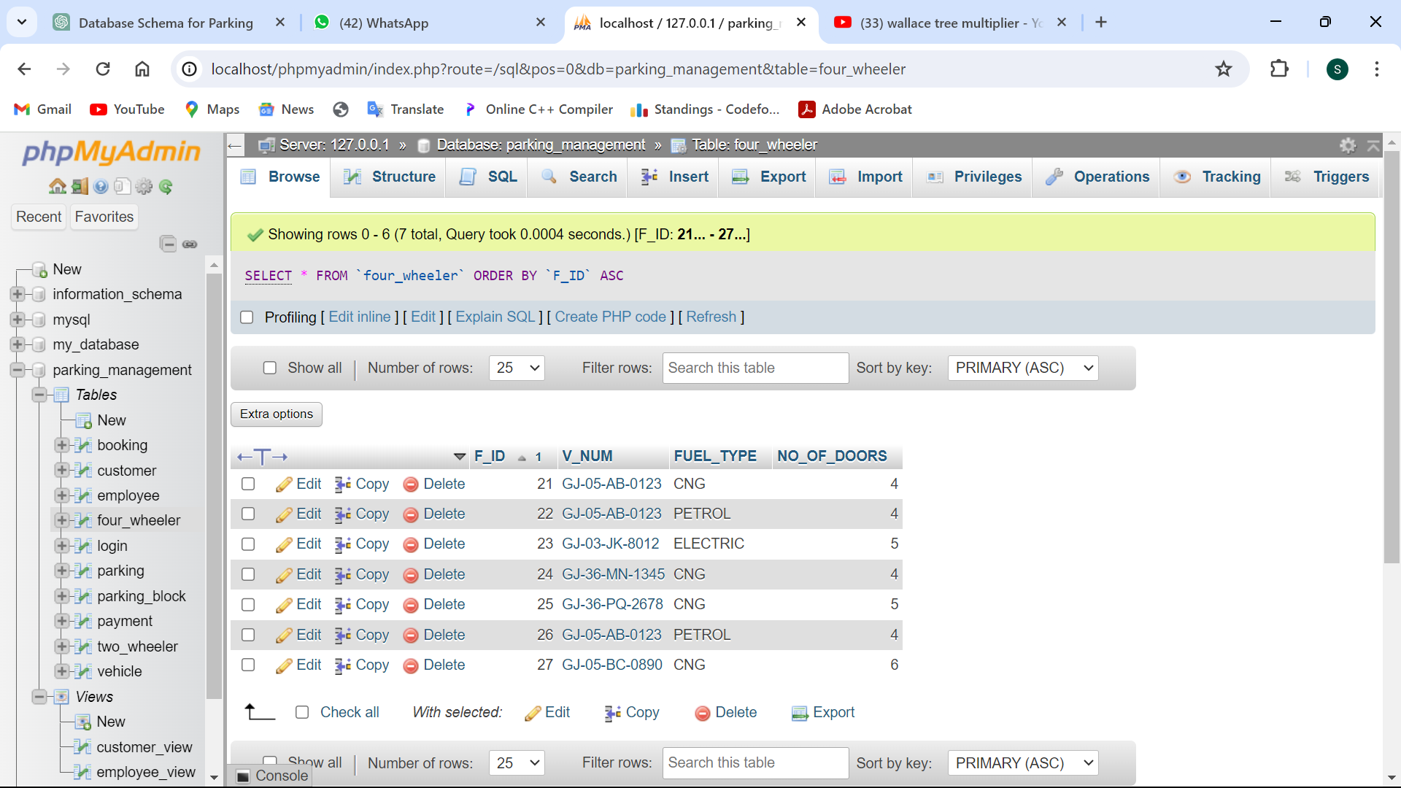

## Functionalities of database:

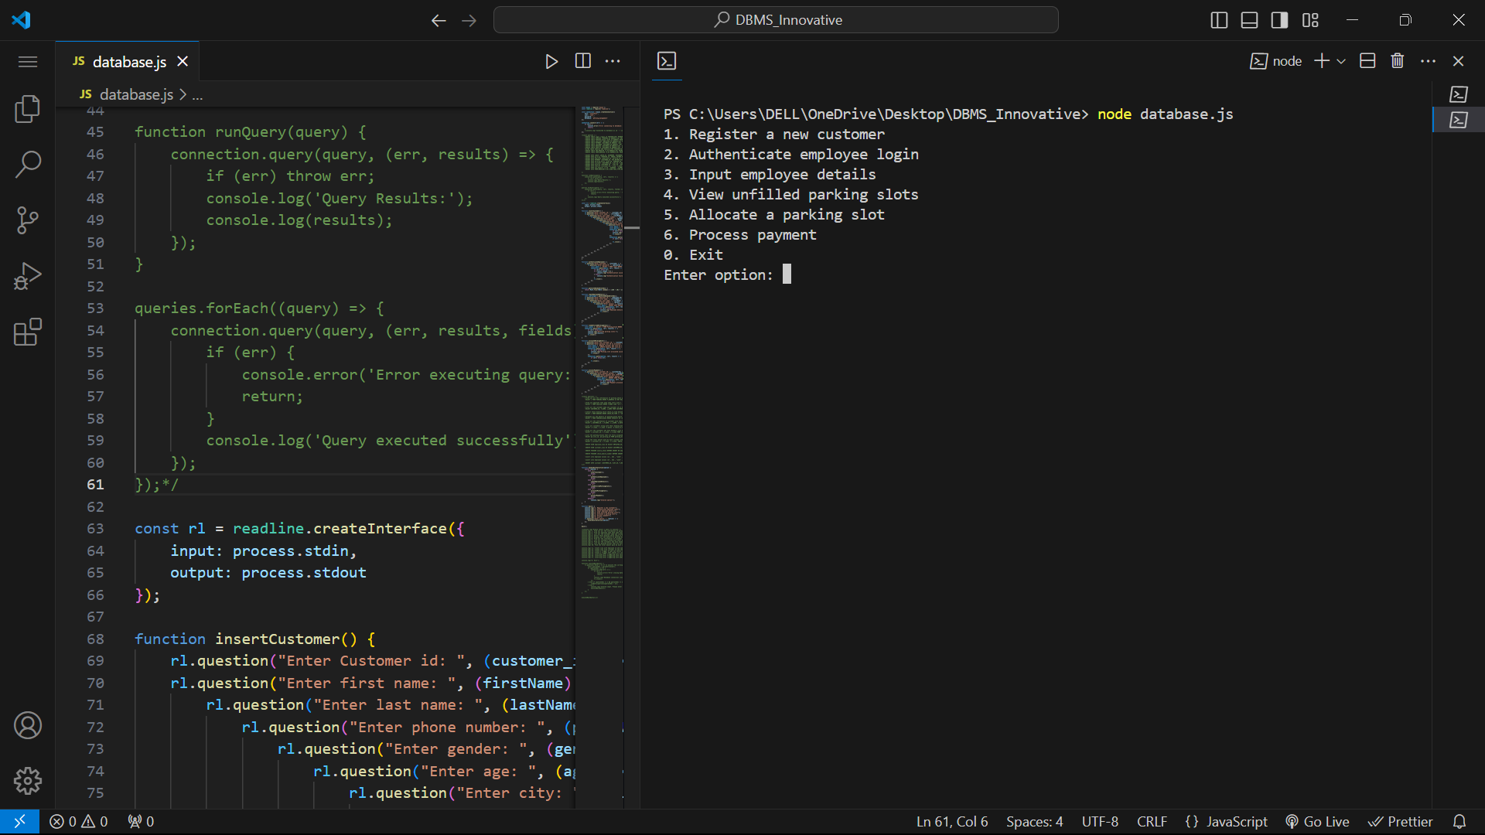

1. Register a new customer

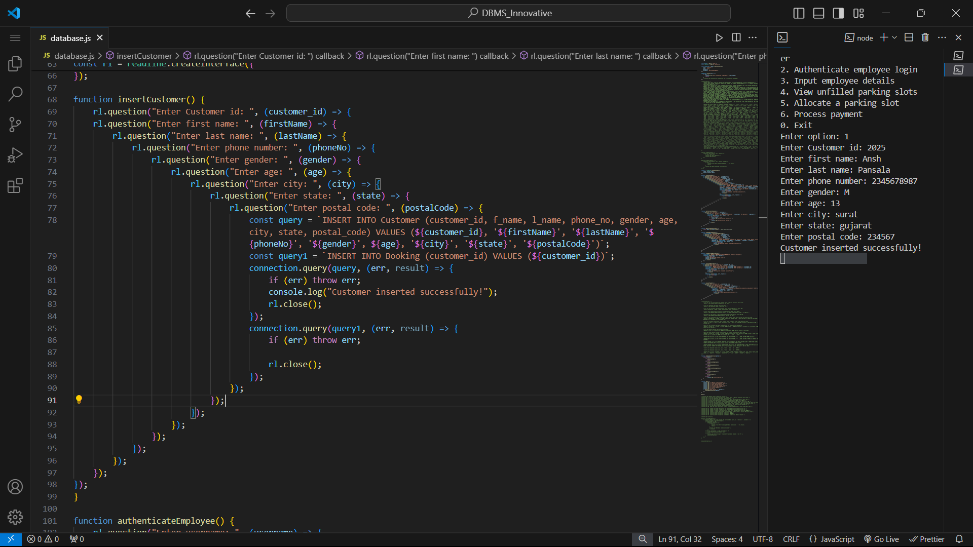

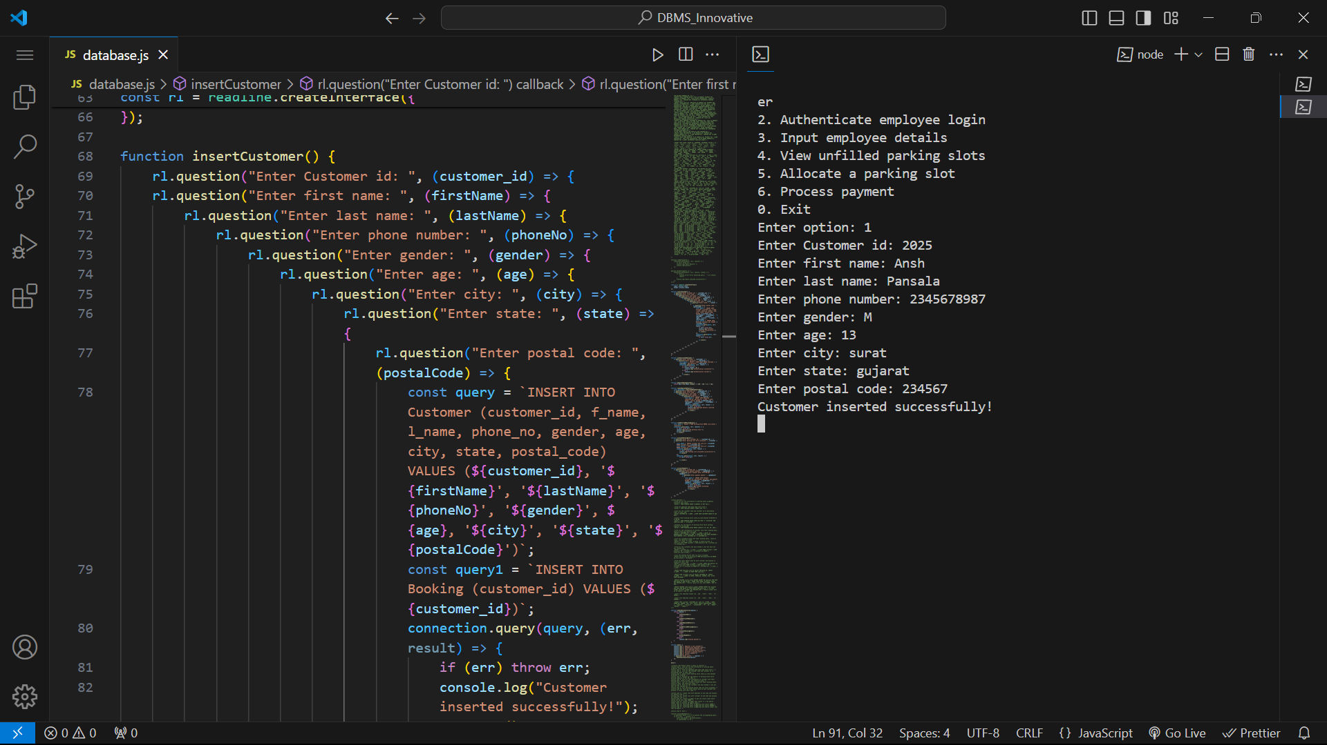

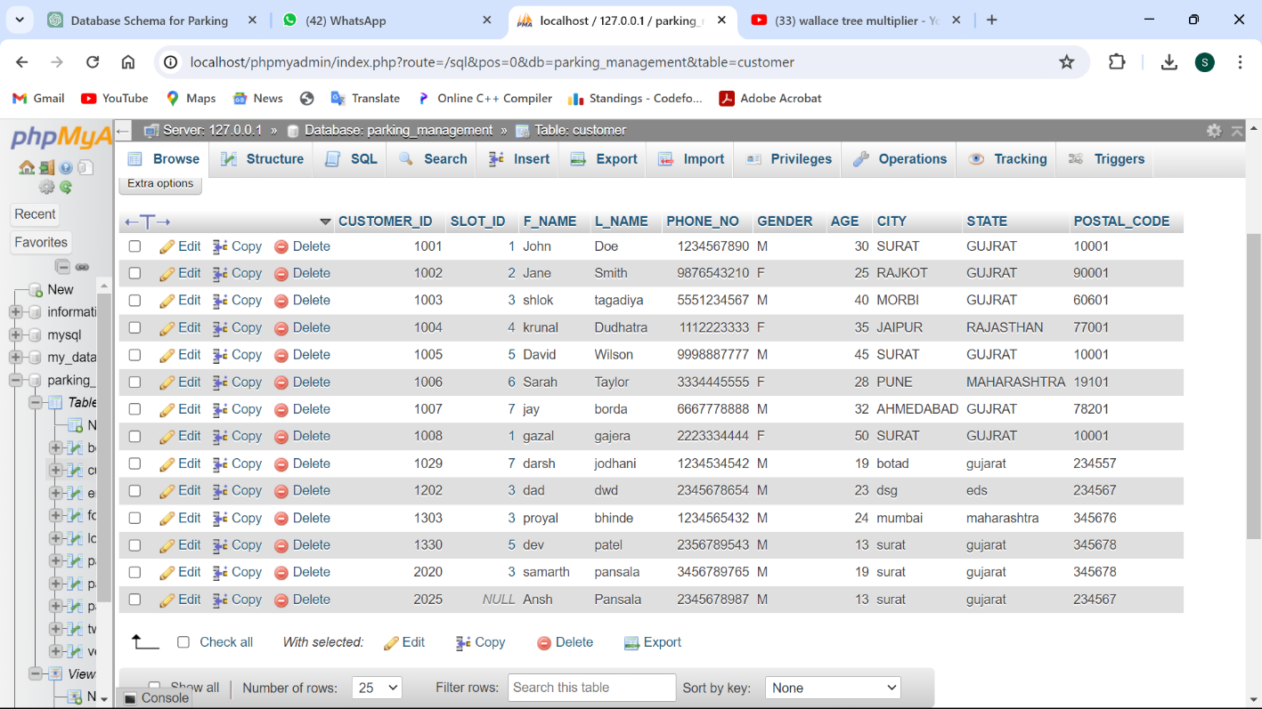

1. Authenticate employee login

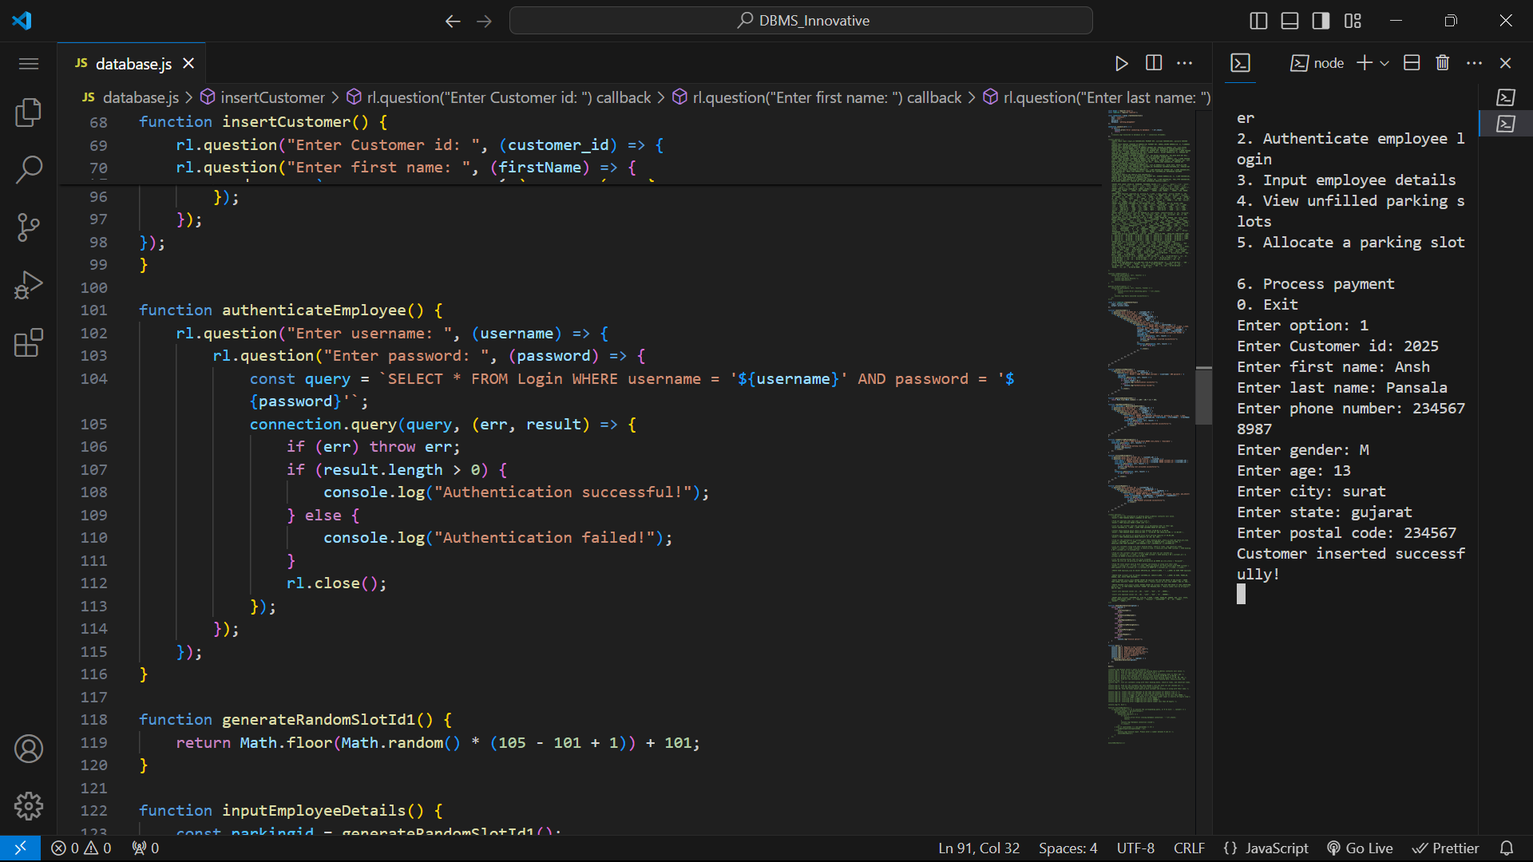

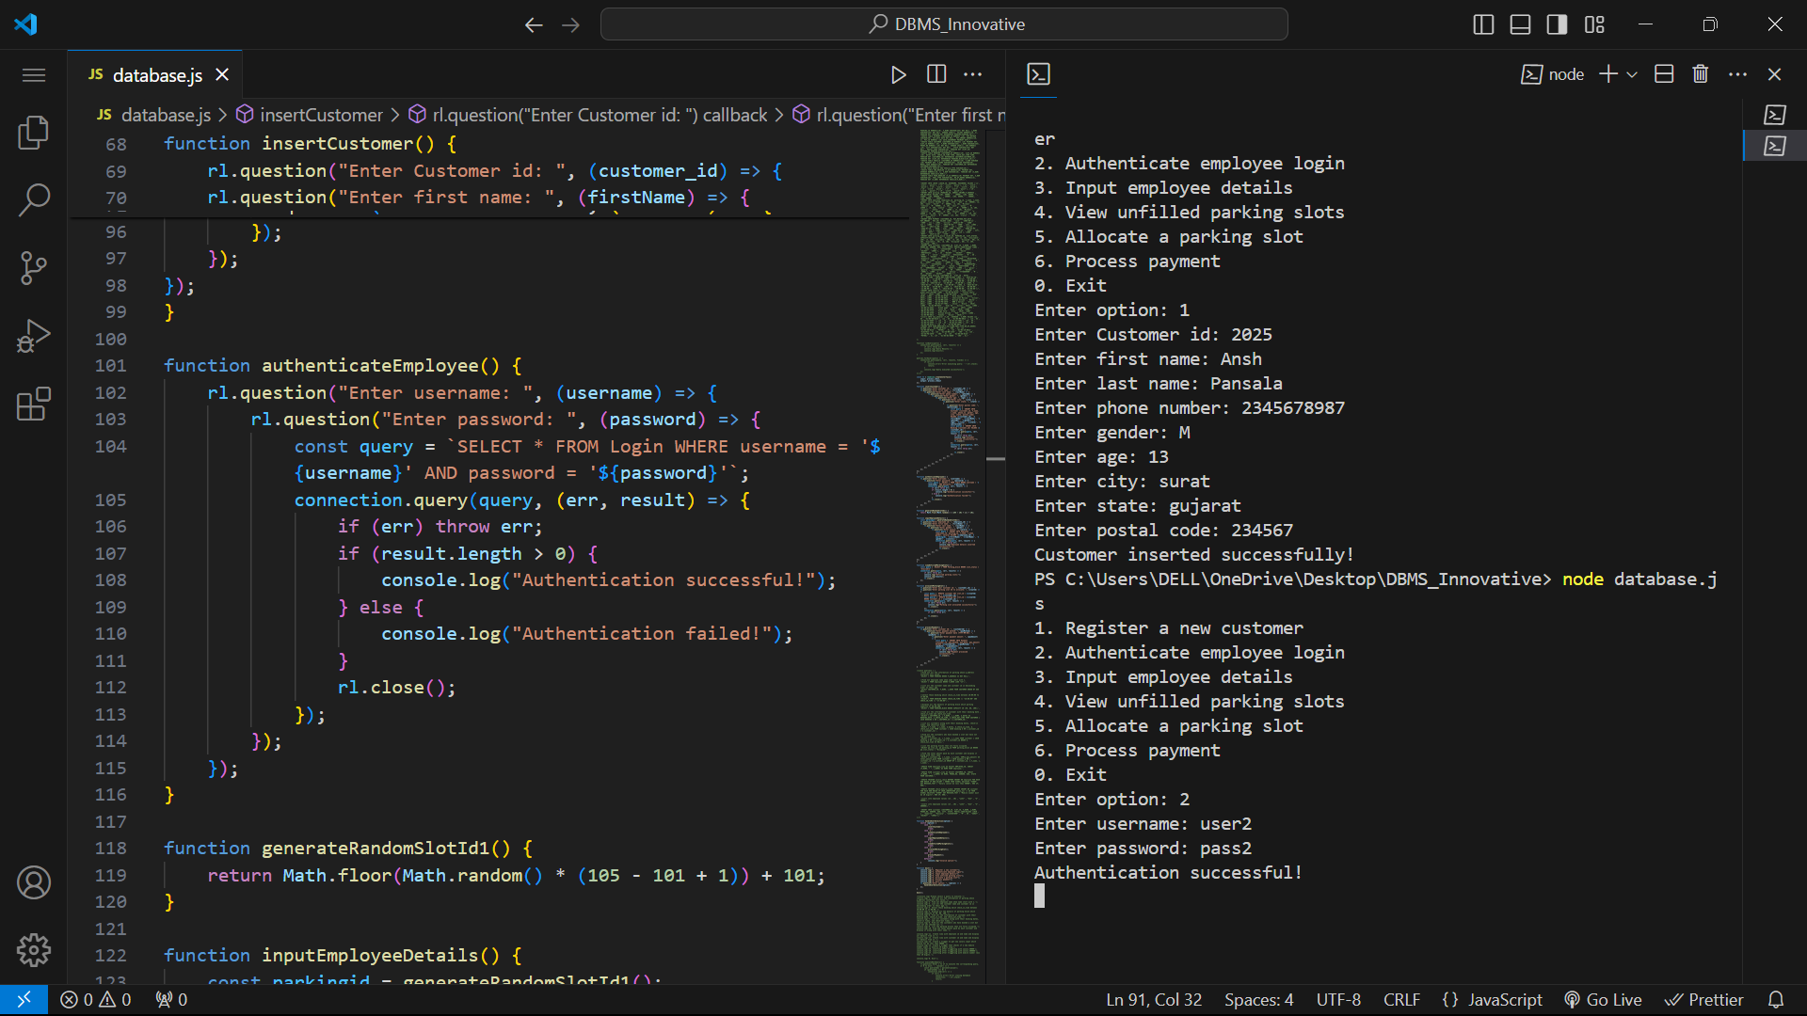 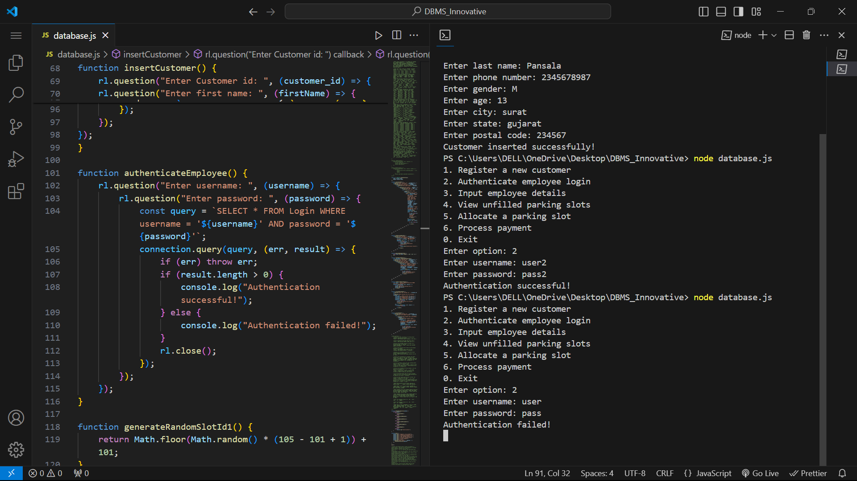

1. Input employee details

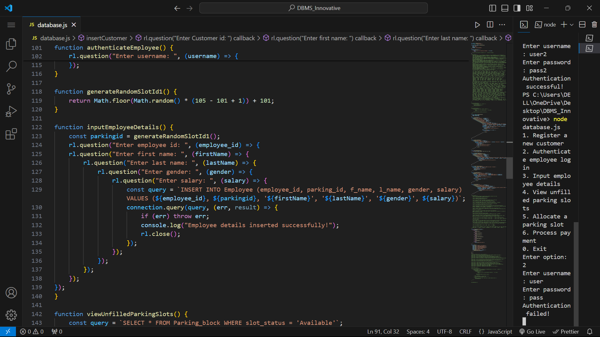

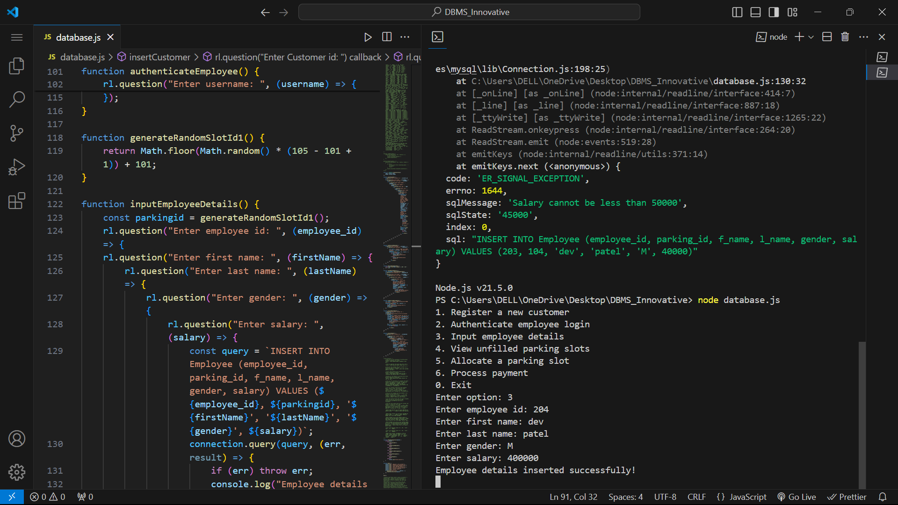

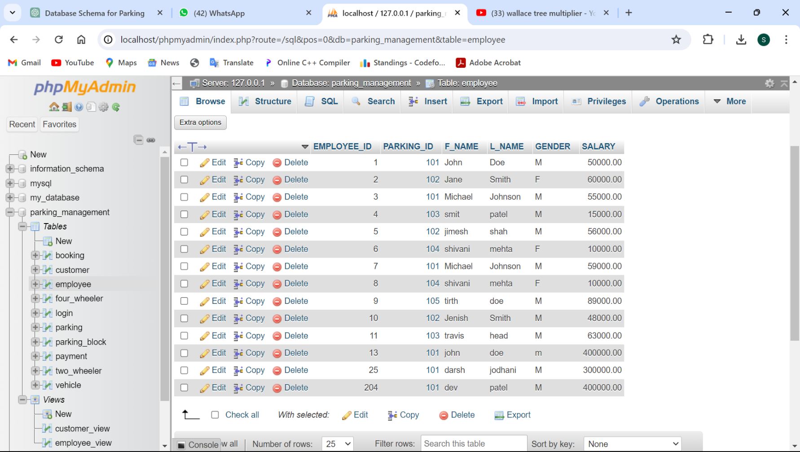

1. View unfilled parking slots

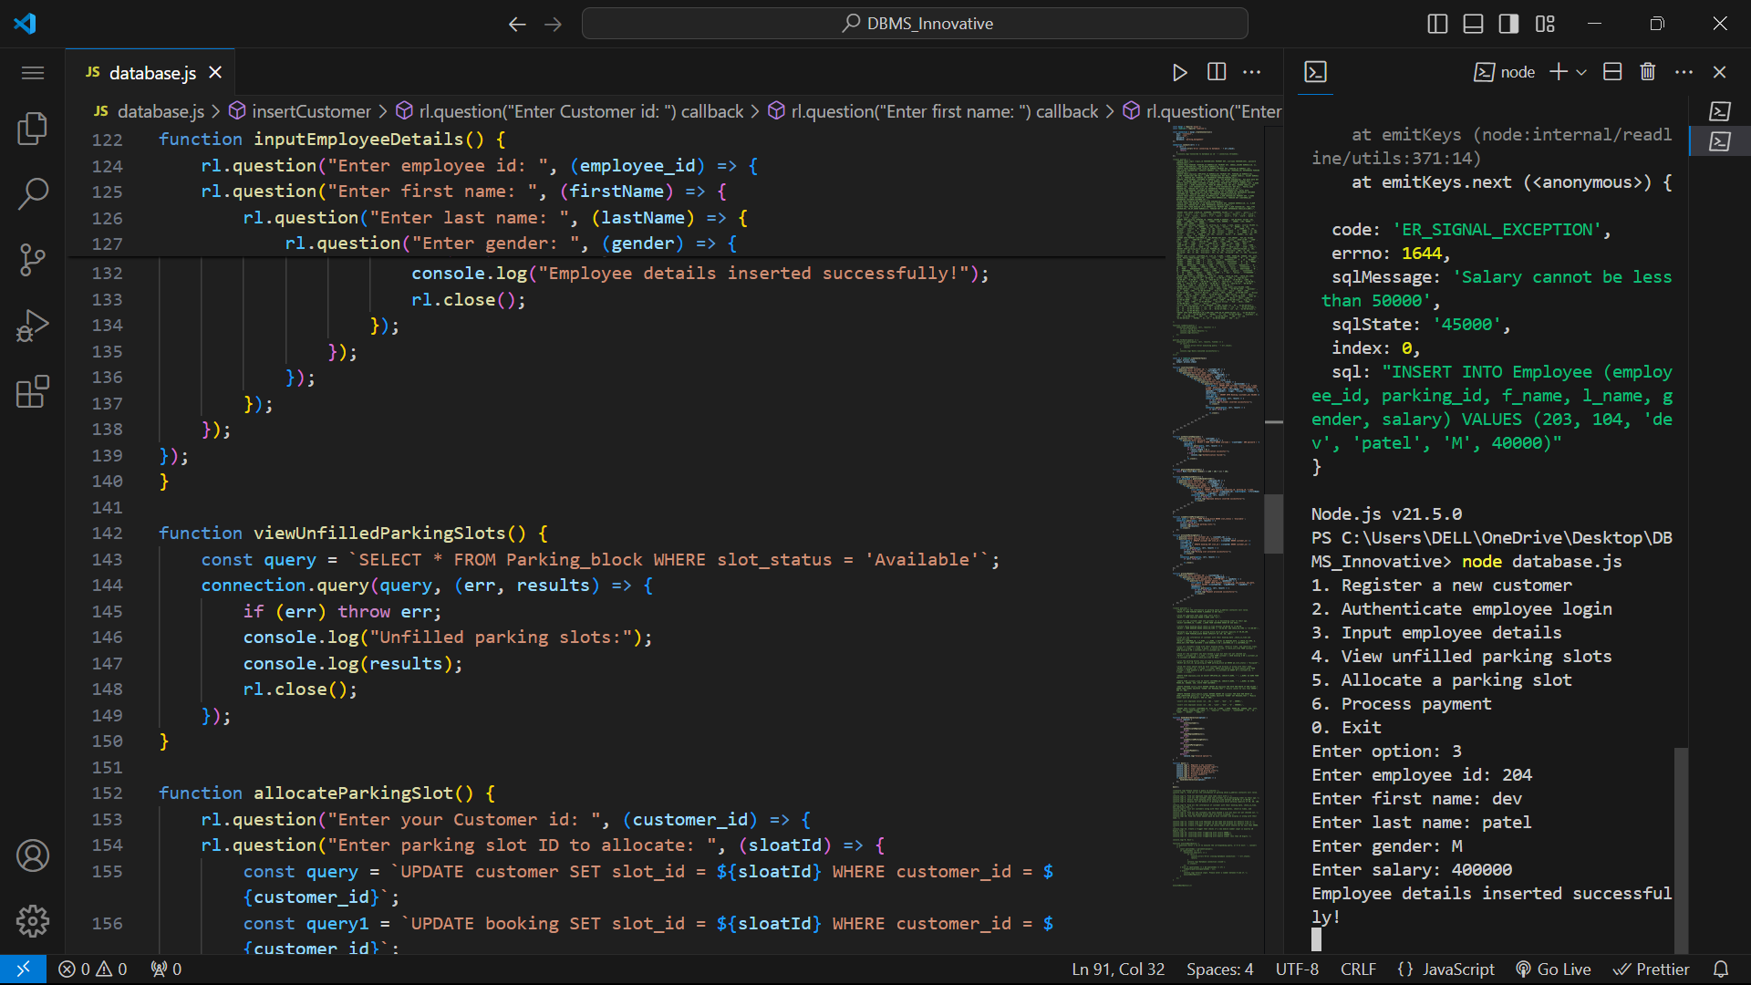

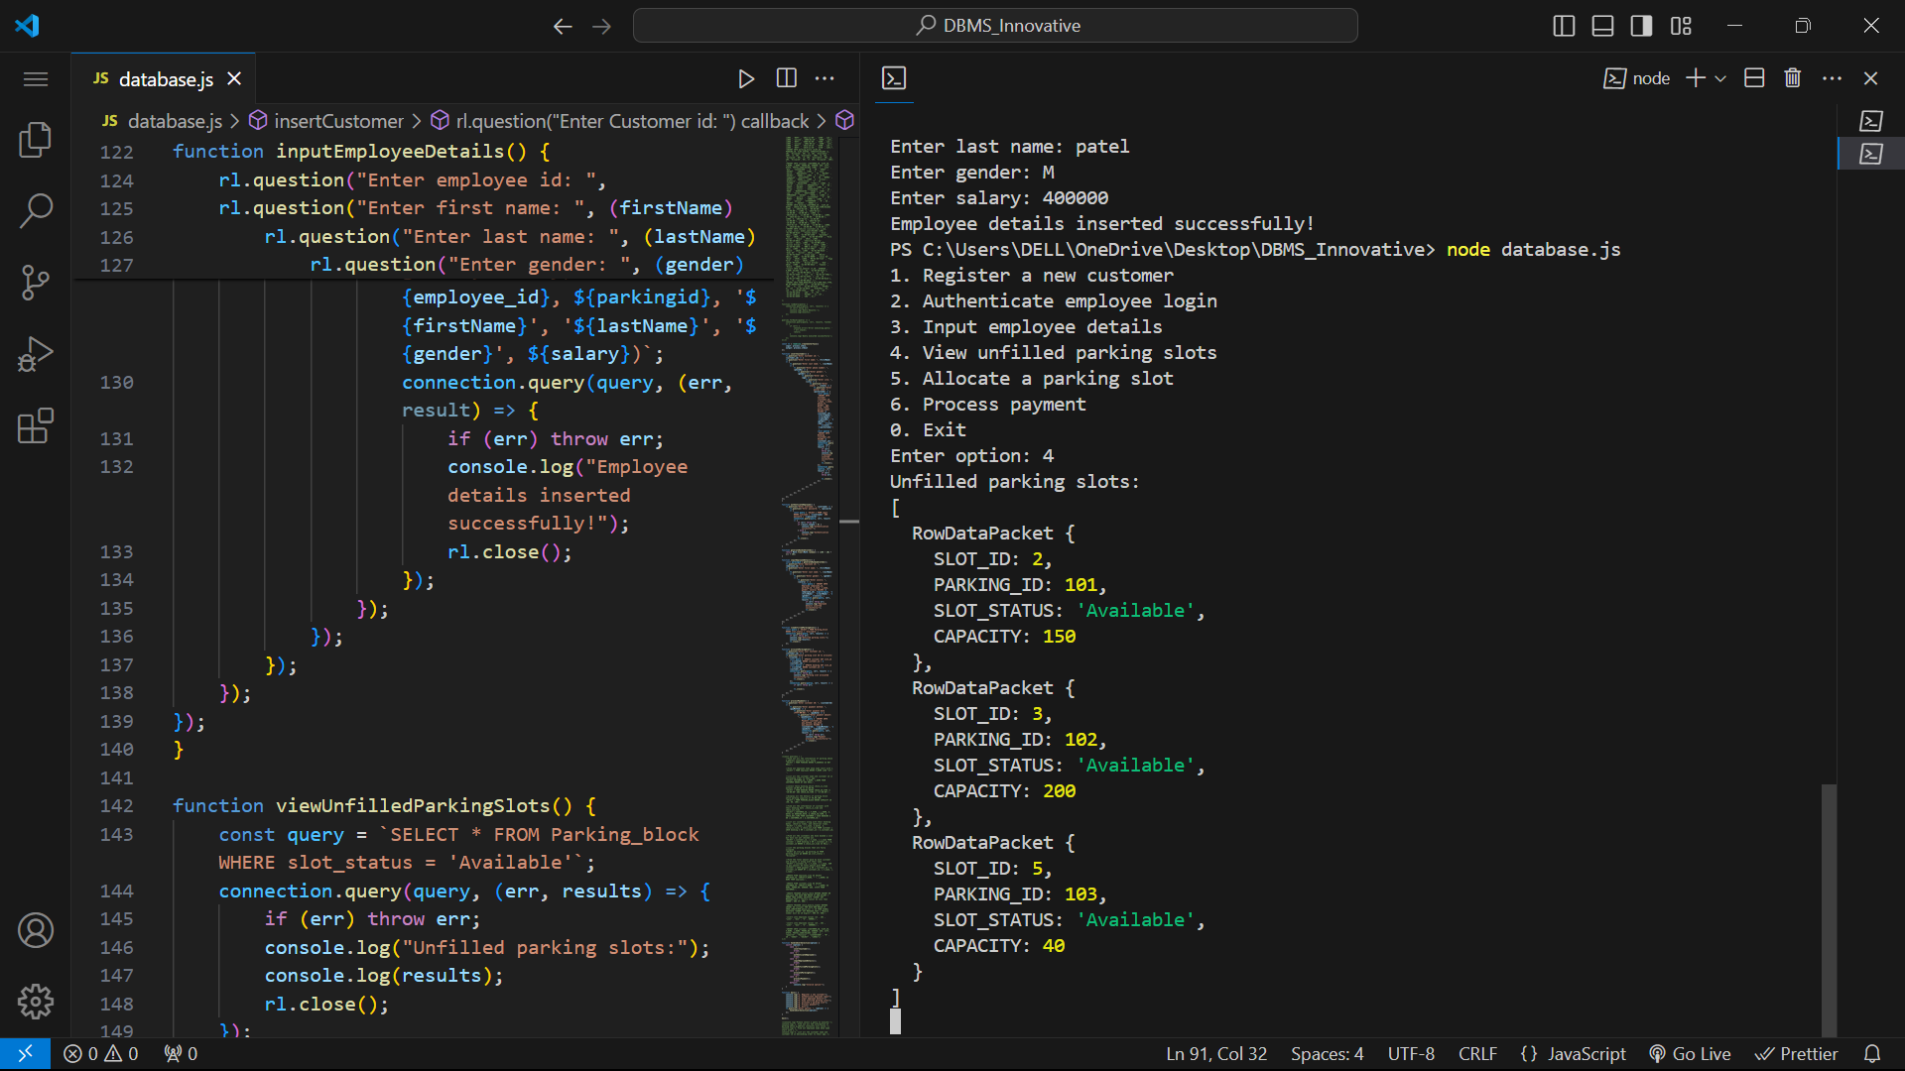

1. Allocate a parking slot

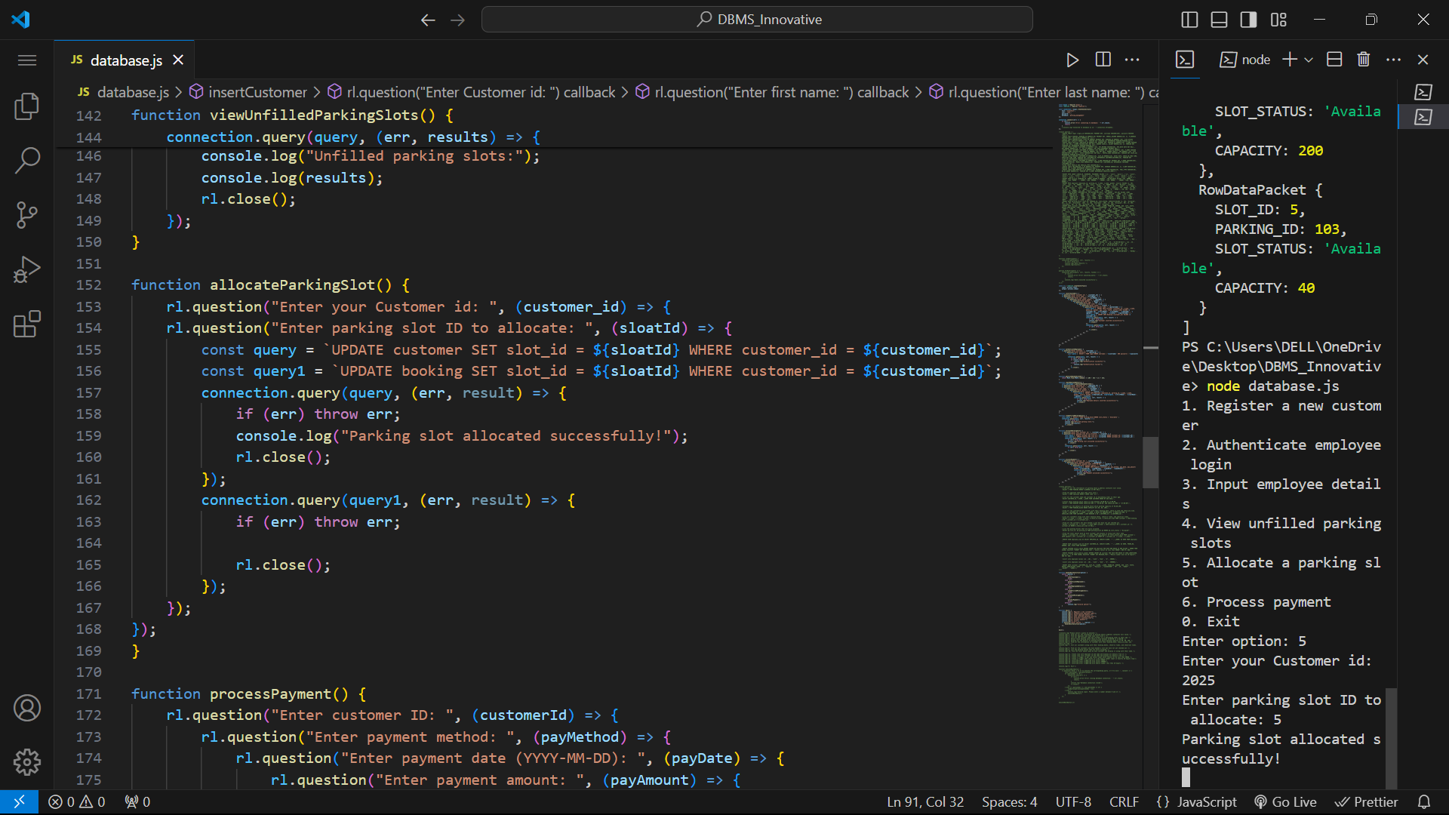

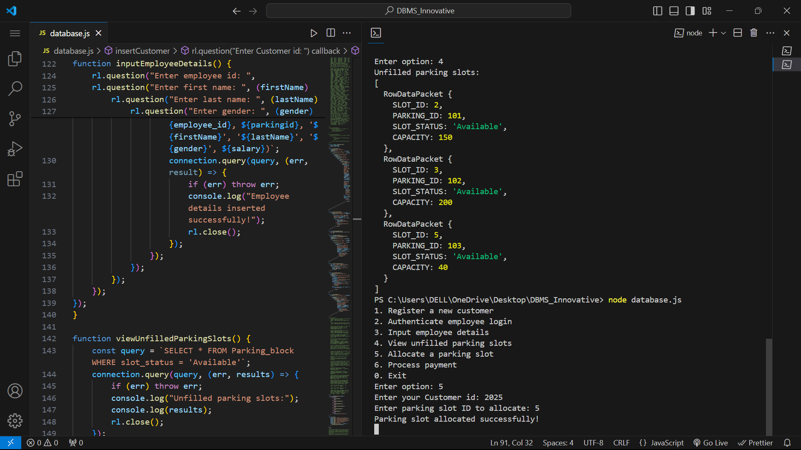

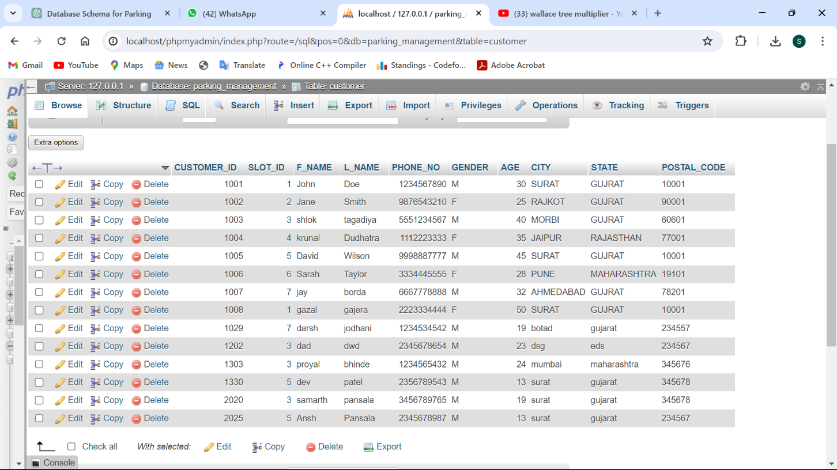

1. Process payment

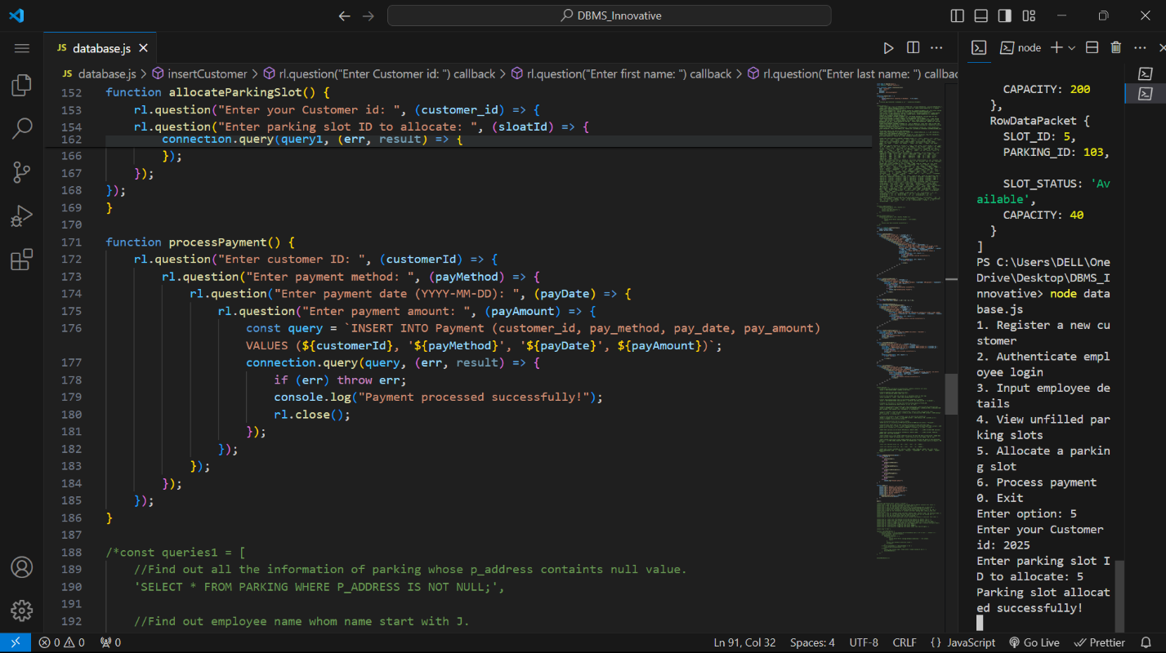

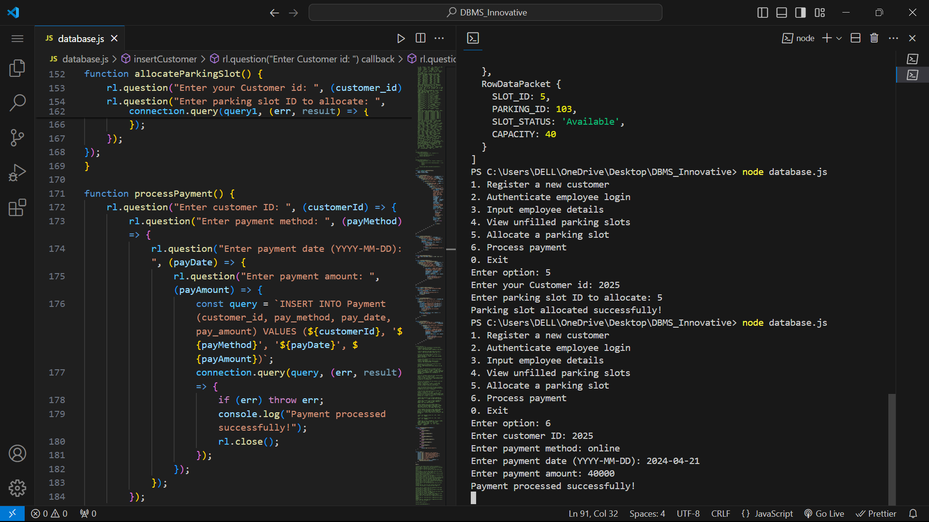

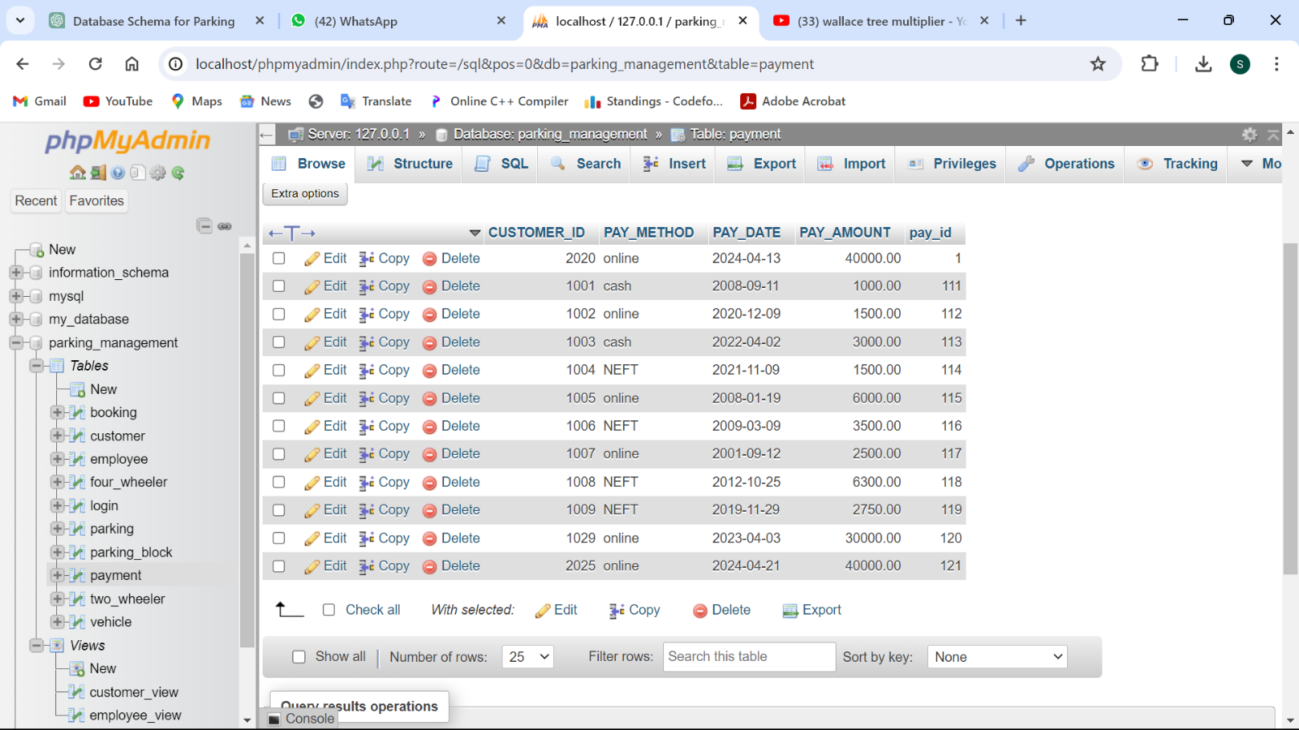

## Queries using DBMS constructsjoin and subqueries:

1. Find the total amount paid by each customer and display it along with their name.

SELECT c.customer_id, c.f_name, c.l_name, SUM(p.pay_amount) AS total_amount_paid FROM customer c JOIN payment p ON c.customer_id = p.customer_id GROUP BY c.customer_id, c.f_name, c.l_name;

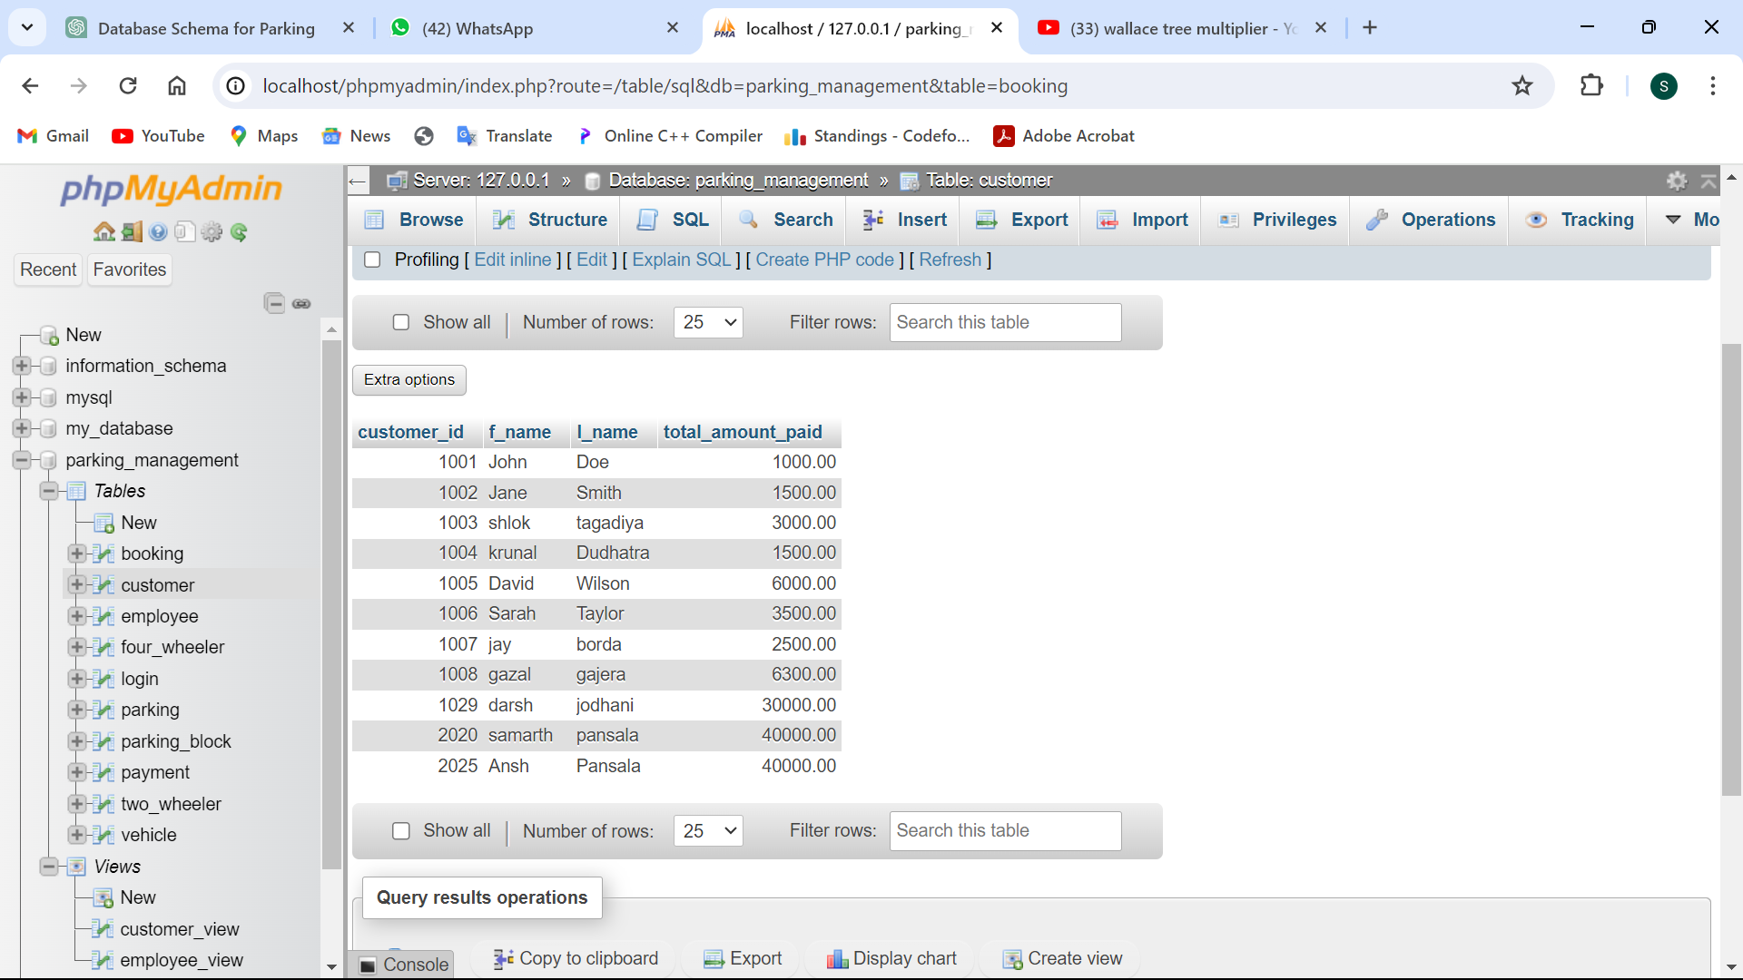

1. Get all customers who have made payments, along with their payment details, assigned parking slot, and vehicle information.

SELECT c.customer_id, c.f_name, c.l_name, c.phone_no, c.gender, c.age, c.city, c.state, c.postal_code, p.pay_id, p.pay_method, p.pay_date, p.pay_amount, cb.slot_id, cb.slot_status, v.v_num, v.v_name, v.color, v.model_year FROM Customer c JOIN Payment p ON c.customer_id = p.customer_id LEFT JOIN Parking_block cb ON c.slot_id = cb.slot_id LEFT JOIN Vehicle v ON c.customer_id = v.customer_id;

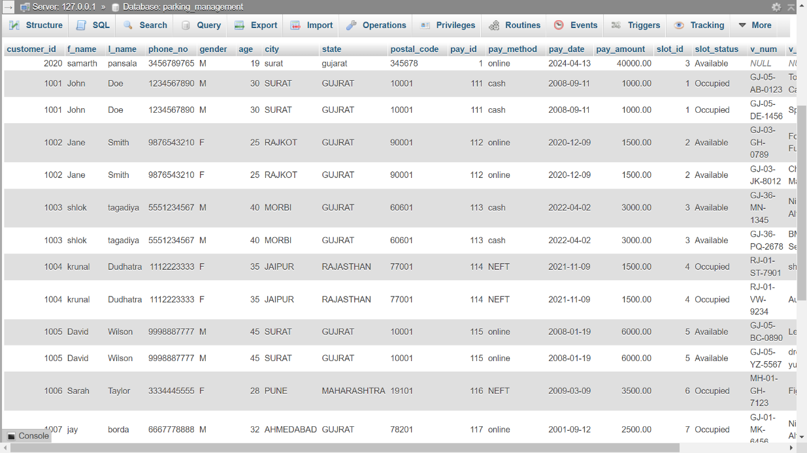

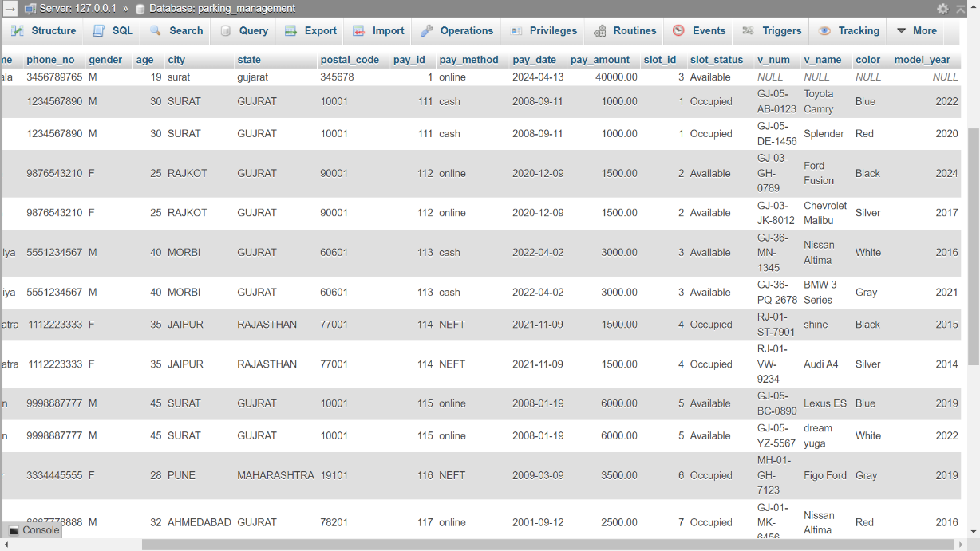

1. Get all customers along with their vehicle details and the average fuel consumption for each two-wheeler they own.

SELECT c.customer_id, c.f_name, c.l_name, c.phone_no, c.gender, c.age, c.city, c.state, c.postal_code, v.v_num, v.v_name, v.color, v.model_year, tw.average AS two_wheeler_avg_fuel_consumption FROM Customer c LEFT JOIN Vehicle v ON c.customer_id = v.customer_id LEFT JOIN Two_wheeler tw ON v.v_num = tw.v_num;

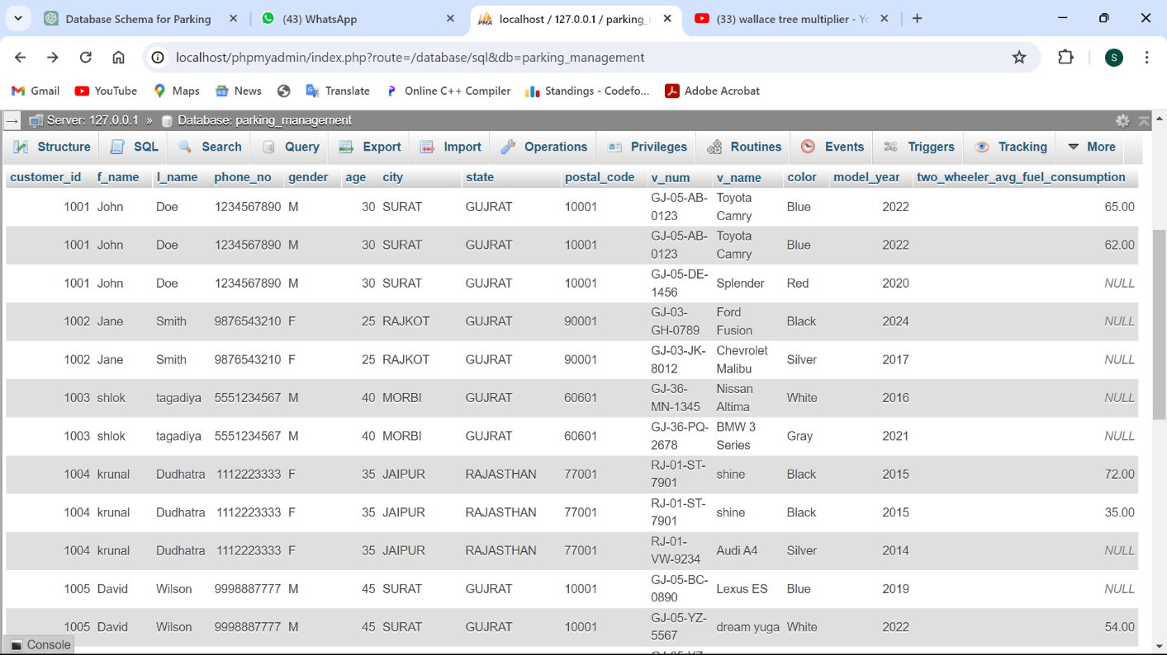

## **Advance Concepts:** PL/SQL(VIEWS):

1. Create view with employee id and name and display all details from it.

CREATE VIEW employee_view AS SELECT EMPLOYEE_ID, CONCAT(F_NAME, " ", L_NAME) AS NAME FROM employee;

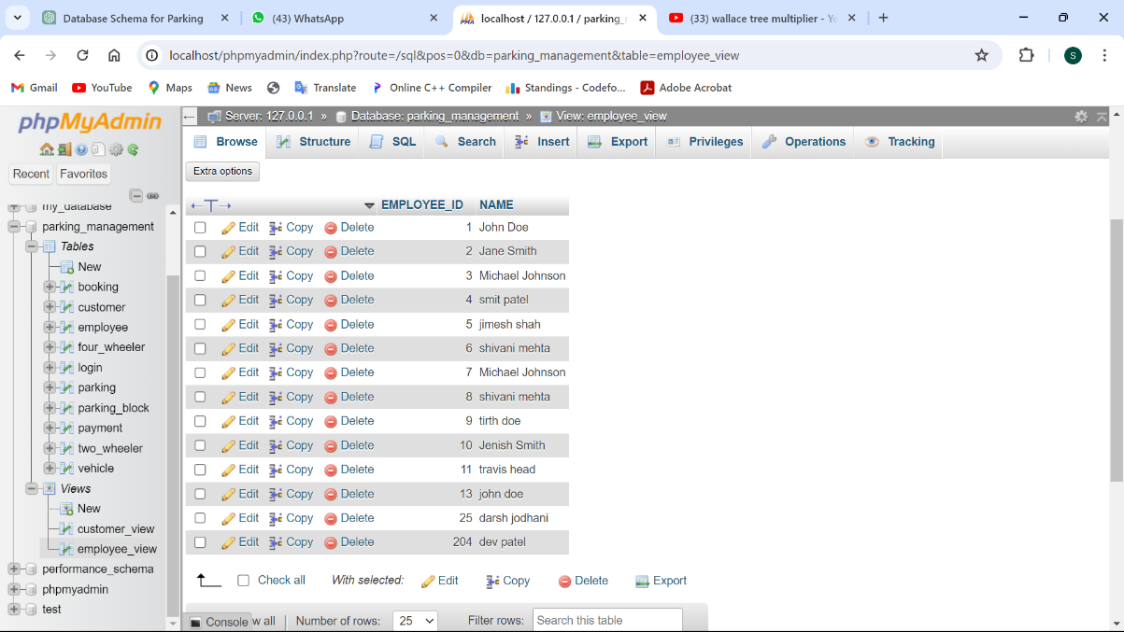

1. Create view with customer id and name and display all details from it.

CREATE VIEW customer_view AS SELECT CUSTOMER_ID, CONCAT(F_NAME, " ", L_NAME) AS NAME, PHONE_NO, GENDER, AGE, STATE FROM CUSTOMER;

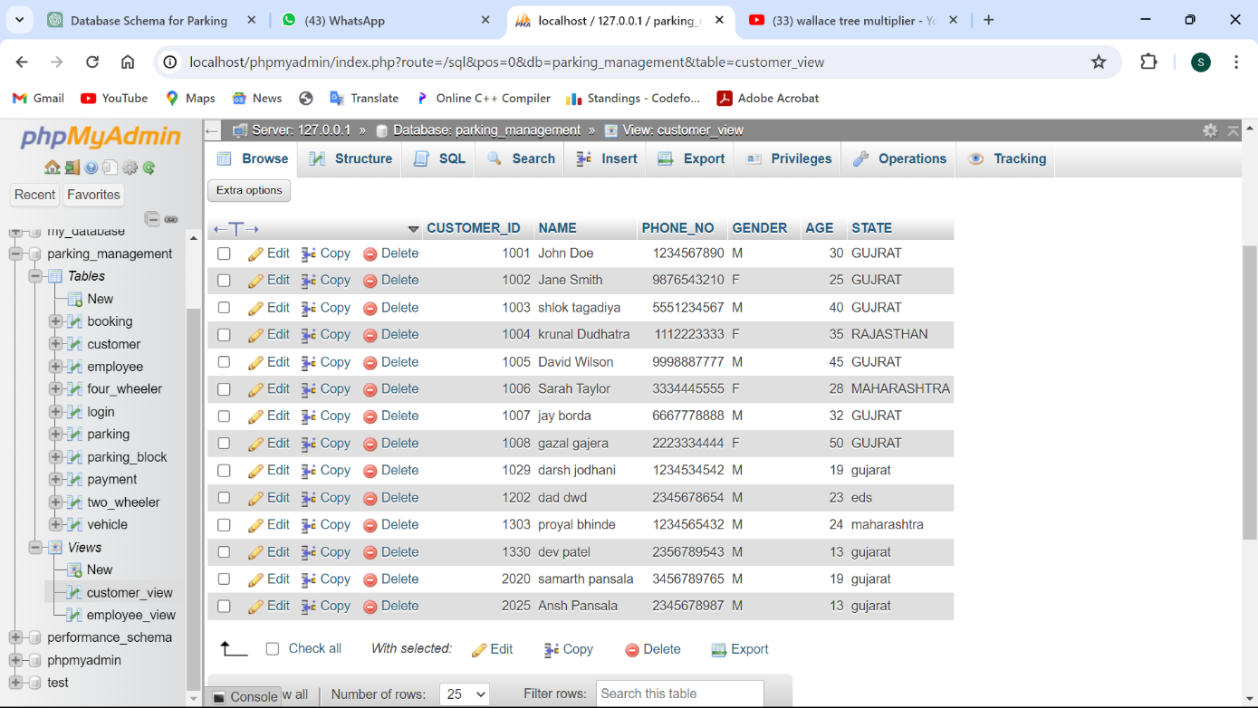

## TRIGGERS:

1. Create a trigger to get new salary input which should not be less than 50000.

CREATE TRIGGER salary_check BEFORE INSERT ON employee FOR EACH ROW BEGIN IF NEW.SALARY < 50000 THEN SIGNAL SQLSTATE "45000" SET MESSAGE_TEXT = "Salary cannot be less than 50000"; END IF; END;

Check: insert into employee values (12 , 101 , "john" , "doe" , "m" , 40000);

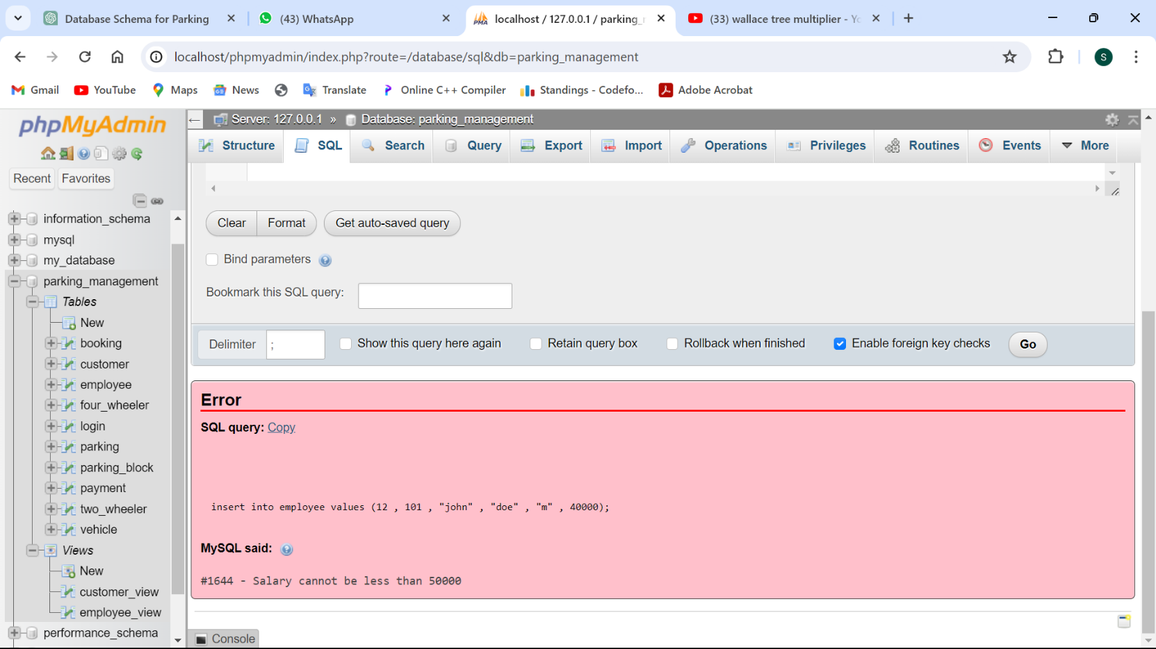

1. Create a trigger to get new mobile no. input which should must be 10 digit.

CREATE TRIGGER check_mobile_number BEFORE INSERT ON customer FOR EACH ROW BEGIN IF CHAR_LENGTH(NEW.phone_no) != 10 THEN SIGNAL SQLSTATE "45000" SET MESSAGE_TEXT = "Mobile number must be 10 digits"; END IF; END;

Check: INSERT INTO customer (CUSTOMER_ID, SLOT_ID, F_NAME, L_NAME, PHONE_NO, GENDER, AGE, CITY, STATE, POSTAL_CODE)VALUES (1020 , 1 , "Samarth" , "Pansala" , "123456789" , "M" , 30 , "SURAT" , "GUJRAT" , "10001");

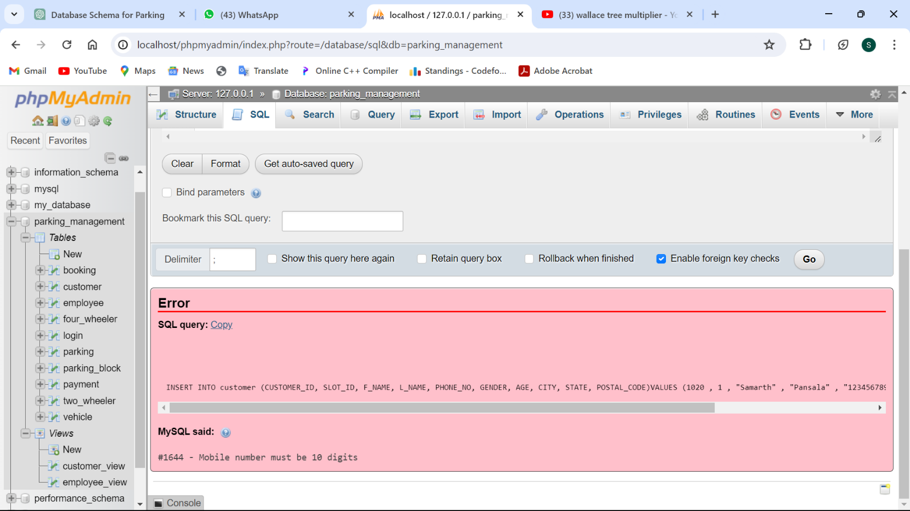

**Learning And Outcome:**

* Knowledge of Database Management Systems (DBMS): This project provides a thorough grasp of the planning and execution of a database management system.Practices are applied for ideas like entity-relationship modeling, normalization, and data manipulation.
* Designing the schema and modeling the data entails figuring out what entities are, what their characteristics are, and how they relate to one another. It entails building associations between tables, specifying primary and foreign keys, and constructing tables.
* Database Implementation: Converting SQL statements for table formation, constraint definition, and data insertion from the schema design. Recognizing the relationships, restrictions, and data types in SQL.
* Learning how to enter data into tables while maintaining data integrity is known as "data insertion and manipulation." Proficiency in utilizing SQL queries to obtain, modify, and remove information.
* Recognizing Relational Models and ER Diagrams: ER diagrams are used to show the relationships between entities in a database. creating relationships between tables and putting the relational paradigm into practice.
* Normalization: Assuring data integrity and effective storage by standardizing the database to reduce redundancy and reliance.
* Functionality Implementation: This involves putting in place a number of functionalities, including payment processing, parking slot distribution, employee verification, and user registration. Recognizing user needs and converting them into database actions.
* Reporting and Querying: Crafting intricate SQL queries to obtain particular data according to specifications. Creating reports by merging information from several tables.

**Conclusion:**

The project's Parking Management System offers a practical way to deal with the increasing parking problems in cities. The following advantages of the system are provided by utilizing database management system concepts and techniques:

* Efficient Parking Management:

Users of the system can make reservations for parking spaces, verify whether any parking spots are available, and effectively distribute parking spaces.

It facilitates better parking experiences overall, lessens traffic, and maximizes the use of available parking spots.

* Data-Driven Decision Making:

The system allows parking operators and city planners to make data-driven decisions by collecting, organizing, and evaluating parking-related data.

Planning infrastructure development, improving urban mobility, and optimizing parking operations are all possible with the help of the data.

* User-Friendly Interface:

Customers and staff can easily register, authenticate, and access parking-related services with the system's user-friendly interface.